./

GENESIS - Learning Outcome & Mini-project Summary Report



|  |  |  |  |  |  |
| --- | --- | --- | --- | --- | --- |
| **Ver. Rel. No.** | **Release Date** | **Prepared. By** | **Reviewed By** | **To be Approved** | **Remarks/Revision Details** |
|  | 16/04/2021 | Vipul Sakunia  PS No- 99003723 |  |  |  |
|  |  |  |  |  |  |
|  |  |  |  |  |  |
|  |  |  |  |  |  |
|  |  |  |  |  |  |

**Details**

Contents

Contents 3

Table of Figures 6

Applied SDLC-CALCULATOR [Team] 9

Module 9

Topic and Subtopics 9

Objectives & Requirements 9

Requirements 9

Introduction 9

Research 10

Cost of the Calculator 10

Features that are integrated in our project calculator are: 10

Defining Our System 10

4WH 10

Detail requirements 11

Design 15

Test Plan 18

Implementation Summary 19

Git Link 19

Git Dashboard 19

Summary 20

Individual Contribution & Highlights 28

Summary 28

Challenges faced and how were they overcome 29

Future Scope 29

Python [Individual] 30

Module 30

Topic and Subtopics 30

Objectives & Requirements 30

High Level requirement analysis 30

Low Level requirement analysis 30

Code and Output 31

Test Plan 34

Git Link 35

Git Dashboard 35

Summary 35

Challenges faced and how were they overcome 35

Embedded-C [ Team] 36

Module 36

Topic and Subtopics 36

Objectives & Requirements 36

Design and Test Plan: 36

Implementation Summary 40

Individual Contribution & Highlights 40

Summary 40

Challenges faced and how were they overcome 40

MBSE [Team] 41

Objectives & Requirements 41

Design 42

Test Plan 47

Implementation Output 48

Implementation Summary 50

Summary 50

Individual Contribution & Highlights 50

Challenges faced and how were they overcome 51

Automotive systems and overview-MBD Evolved[Team] 52

Features 52

Objectives & Requirements 52

High Level Requirements: 52

Low Level Requirements: 52

Design 53

Feature Model 54

Test Plan 58

HIL Testing for TPMS and Exterior Lights 58

Implementation 59

Model Advisor Report 59

MCDC Report 59

Automated Output Result 60

Individual Contribution & Highlights 61

Summary 61

Challenges faced and how were they overcome 61

Canoe and CAPL scripting [ Team] 62

Module 62

Topics and Subtopics 62

Objectives & Requirements 62

Design 62

Test Plan 63

Implementation Summary 64

SharePoint Link 64

SharePoint Dashboard 64

Individual Contribution & Highlights 65

Summary 65

Challenges faced and how were they overcome 65

Control Systems [ Team & Individual] 66

Module 66

Topics and Subtopics 66

Objectives & Requirements 66

Requirements 67

Design for Longitudinal Control 68

Plant Model with P, PI, PD And PID controller 68

Analysis 71

Plant Model with lead lag compensator 72

Transfer Function: 72

Tool Analysis 72

Analysis for Lead Compensator 77

Plant Model with Fuzzy Controller 77

Longitudinal Control with Disturbance using PI, PD, PID Control. 78

Analysis 82

SharePoint Link 83

Individual Contribution & Highlights 83

Pitch Control for Drone 83

Math Analysis 83

Pitch control of drone with controllers 83

Tool Analysis 83

Analysis and Time Response result 87

SharePoint Link 88

Implementation Summary 88

Summary 88

Individual Contribution & Highlights 88

Challenges faced and how were they overcome 88

## Table of Figures

Figure 1 HLR Structural 15

Figure 2 LLR Sequence Diagram 16

Figure 3 LLR Structural 17

Figure 4 Power function UML 18

Figure 5 Git dashboard 20

Figure 6 Git Dashboard 1 20

Figure 7 Inspector Summary 21

Figure 8 Setup Git 22

Figure 9 Build 22

Figure 10 Built Action 23

Figure 11 Setup Alignment 23

Figure 12 Cpp check 24

Figure 13 Cpp Run Check 24

Figure 14 Issues 25

Figure 15 Unit Testing setup 26

Figure 16 Unit testing Outcome 26

Figure 17 Unit Testing Outcome2 28

Figure 18 Code Python 32

Figure 19 Output Python 1 33

Figure 20 Output Python 2 34

Figure 21 Git dashboard Python 35

Figure 22 Pin Configuration 36

Figure 23 Code Snippet for Hatch Control 37

Figure 24 Microcontroller implementation of Hood control from switch 37

Figure 25 Code snippet for Exterior Lighting 38

Figure 26 MC implementation of Exterior lights using LDR sensor 38

Figure 27 Code snippet for Interior lighting 39

Figure 28 Image of the microcontroller implementation of interior lighting (Pink Light) 39

Figure 29 Code snippet for Wiper control 39

Figure 30 Microcontroller implementation of Wiper Control 39

Figure 31 High Level MBSE Design 42

Figure 32 MBSE Input 43

Figure 33 MBSE Output 43

Figure 34 Dashboard 44

Figure 35 MBSE Plant 44

Figure 36 Engine Status/Key Ignition 45

Figure 37 Power Outlet 45

Figure 38 Gear Control 46

Figure 39 Gear Control State flow 46

Figure 40 Seat Belt reminder MBSE 47

Figure 41 SBR Sate flow Implementation MBSE 47

Figure 42 Output for Manual Implementation 1 49

Figure 43 Output for Manual Implementation 2 50

Figure 44 High level Design 53

Figure 45 Low Level design 53

Figure 46 Evolved Plant 54

Figure 47 Seat Belt reminder model 54

Figure 48 Gear Control for Input to SBR 55

Figure 49 Gear Implementation State Flow 55

Figure 50 SBR low level model 56

Figure 51 State flow for SBR 56

Figure 52 Algorithm SBR 57

Figure 53 SWOT for SBR 58

Figure 54 HIL testing for TPMS 58

Figure 55 HIL testing for Exterior Lights 59

Figure 56 Model advisor for whole model 59

Figure 57 MCDC report 60

Figure 58 Automated Output for SBR and Gear 60

Figure 59 Dashboard Canoe 62

Figure 60 Speedometer 63

Figure 61 Mode switch, Break and Throttle control 63

Figure 62 Trace Canoe 64

Figure 63 SharePoint Dashboard 65

Figure 64 Longitudinal Control 66

Figure 65 Plant Model PID 68

Figure 66 PID scope output 69

Figure 67 Bode Plot P 69

Figure 68 Bode Plot PI 70

Figure 69 Bode Plot PD 70

Figure 70 Bode Plot PID 71

Figure 71 Main TF response 74

Figure 72 Pole Zero Map of main TF 74

Figure 73 Response with Lead-Lag Controller 75

Figure 74 Lead Lag Pole Zero Map 76

Figure 75 Bode Plots 76

Figure 76 Fuzzy Logic Implementation 77

Figure 77 Fuzzy Bode Plot 78

Figure 78 Fuzzy Output 78

Figure 79 PID with Disturbance 79

Figure 80 Disturbance with PI Output 79

Figure 81 Disturbance with PD Output 80

Figure 82 Disturbance with PID Output 80

Figure 83 Bode Plot PI 81

Figure 84 Bode Plot PD 81

Figure 85 Bode Plot PID 82

Figure 86 Step Response Drone 86

Figure 87 Response with Controllers 86

Figure 88 Bode Plots for Drone PID 87

Figure 89 Pole Zero Map 88

# Applied SDLC-CALCULATOR [Team]

## Module

Modules linked to the calculator project is Applied SDLC and C Programming.

### Topic and Subtopics

The topics which I mainly focused on are UML diagrams, different software life cycles, usage of software tools (VScode ), creation and installation of make file, learning about how to use GitHub and how to do continuous integration of the team code, SWOT Analysis and 4 WH questions to justify the objective.

* Software Life Cycles:

Mainly focused on Agile model, V model and their advantages, disadvantages and how it affects the cycle of development.

Learnt about release cycles & development cycles. In development life cycles, we have different stages named as Pre-alpha, Alpha, Beta, Release Candidate.

* GITHUB and GIT Desktop:

1. How to make the repositories.
2. How to push and pull the code in and out of the repositories using git Desktop and through git commands.
3. Learnt about how to generate Make file in VScode.
4. Continuous Integration in GITHUB and learnt about GIT inspector
5. Learnt about how to raise issue and solve the issues and learnt about the difference between branch and main and raised a request to merge the branch in to main.

* UML diagrams:

1. UML- “unified modeling language” learnt there are 2 categories namely structural, behavioral

and chose different models in structural, behavioral model which fits according to the objective

1. Took state structural model and class behavioral model for the low-level requirement and Deployment behavioral model for the High-level requirement.

* Testing:

1. Testing types functional testing and nonfunctional testing and learnt that Nonfunctional testing has no impact on the features.
2. In the functional testing, we have different types namely Boundary value test, Requirement based test, Scenario based test.

## Objectives & Requirements

## Requirements

The calculator build by us includes basic arithmetic functions, trigonometric functions and exponential functions. It also consists of some other functions including power, log, antilog, permutation and combination functions.

## Introduction

We have attempted to build the software development cycle of a semi-engineering calculator. It includes the numerous high-level and low-level requirements of the various features involved in semi-engineering such as log, antilog, exponents roots and polynomial functions. It then explores about the various test cases that should be taken in consideration such that all requirements are taken care of. In the end, we build the codes that follow all the requirements and design efficiently as per them.

## Research

There are different types of calculators with respect to the cost and its features. It is plotted in the graph shown below which shows the range of calculators for highest cost and lowest feature and vice versa. The range we have chosen is for a medium range cost and feature. It is similar to a programmable scientific calculator. It will be more efficient for the multipurpose use.

## Cost of the Calculator

* Our Calculator will sum around 800 Rupees, having all necessary features required for all students
* Cost and features mainly focus on most of the important requirements we researched for a calculator.

## Features that are integrated in our project calculator are:

* Will perform basic Addition, Subtraction, division, Multiplication with validation
* Also, it can perform long division approach with remainder and quotient as a result
* Addition of Hexadecimal number
* Calculation of GCD
* Basic Trigonometry operation like Sine, Cos, Tan
* performing the power function i.e. calculating the power of the number
* Integrated with operation like logarithmic and Antilog calculation
* Factorial of numbers and Exponential
* Mean of the numbers
* Conversion of Units

## Defining Our System

Our system is more or less semi advanced which basically able to do desirable calculations of daily basis from bottom to top level i.e. it includes every basic operation which eats lots of time in scheduled timings.

## 4WH

Who:

* School students, college personnel of Science and Engineering, Professionals at industrial level

What:

* Calculate problems in Science, engineering & mathematics. In some aspects of astronomy, physics and chemistry.

When:

* In situations that require quick access to certain mathematical functions (trigonometry, logarithmic, etc.)

Where:

* Widely used in both educational and professional settings (Institutions, laboratories).

How:

* Our calculator is a simple tool that any user can efficiently use at the time of most basic as well as complex calculations.

## Detail requirements

**High Level Requirements:**

|  |  |  |  |
| --- | --- | --- | --- |
| **ID** | **Requirements** | **Description** | **Status** |
| HL001 | CALCULATING NUMBERS | BASIC ARITHMETIC CALCULATION- ADDITION- SUBTRACTION- DIVISION- MULTIPLICATION | IMPLEMENTED |
| HL002 | LOG ANTILOG & POWER OPERATIONS | SOLVING POWER FUNCTIONS AND LOG/ANTILOG OPERATIONS | IMPLEMENTED |
| HL003 | TRIGONOMETRIC FUNCTIONS | SINE- COSINE- TAN | IMPLEMENTED |
| HL004 | PERMUTATION & COMBINATION | PERMUTATION & COMBINATION FORMULAE OUTPUTS | IMPLEMENTED |
| HL005 | CONVERSIONS OF UNITS | UNIT COVERSIONS FOR TEMPERATURE, DEGREE, etc. | IMPLEMENTED |
| HL005 | FACTORIAL | FACTORIAL OF THE POSITIVE NUMBERS | IMPLEMENTED |
| HL007 | LCM & GCD | LCM and GCD OF THE POSSIBLE REAL NUMBERS | IMPLEMENTED |
| HL008 | ROOTS | SQUARE AND CUBE ROOTS OF THE POSITIVE NUMBERS | IMPLEMENTED |

**Low Level Requirements:**

**Arithmetic Operations:**

|  |  |  |  |
| --- | --- | --- | --- |
| **ID** | **Requirements** | **Description** | **Status** |
| LL001 | Addition | Taking two numbers as input and adding them | Implemented |
| LL002 | Subtraction | Taking two numbers as input and subtracting them | Implemented |
| LL003 | Multiply | Taking two numbers as input and multiplying them | Implemented |
| LL004 | Divide | Taking two numbers as input and dividing them | Implemented |

**Log and Antilog operations**

|  |  |  |  |
| --- | --- | --- | --- |
| **ID** | **Requirements** | **Description** | **Status** |
| LL003 | Logarithm | Taking one number as input with base as 10 and finding its log output | Implemented |
| LL004 | Anti-logarithm | Taking one number as input with base as 10 and finding its antilog output | Implemented |

**Trigonometric Operations**

|  |  |  |  |
| --- | --- | --- | --- |
| **ID** | **Requirements** | **Description** | **Status** |
| LL005 | Sine Functions | Finding the sine of a number | Implemented |
| LL006 | Cos Functions | Finding the cos of a number | Implemented |
| LL007 | Tan Functions | Finding the tan of a number | Implemented |

**Permutation and Combination**

|  |  |  |  |
| --- | --- | --- | --- |
| **ID** | **Requirements** | **Description** | **Status** |
| PER_1 | n<R | shows error when N<R | Implemented |
| PER_2 | Formulae calculation Permutation | finds permutation using the formulae | Implemented |
| COM_1 | n<R | shows error when N<R | Implemented |
| COM_2 | Formulae calculation combination | finds combination using the formulae | Implemented |

**Conversion of Units**

|  |  |  |  |
| --- | --- | --- | --- |
| **ID** | **Requirements** | **Description** | **Status** |
| COU_2 | Temperature conversion | converts user input from Celsius to Fahrenheit | Implemented |
| COU_3 | Degree to radian conversion | converts one user input from degree to rad at a time | Implemented |

**Factorial and Power**

|  |  |  |  |
| --- | --- | --- | --- |
| **ID** | **Requirements** | **Description** | **Status** |
| Fac_1 | Factorial | Finding factorial of the given number | Implemented |
| pre_1 | Library | Math library file will be required in coding section. | Implemented |
| pre_2 | power function | Requirement of power function while executing this section of program. | Implemented |
| pre_3 | Data type | Must contain best suited data types else show | Implemented |
| pre_3 | Boundary limit | Limit exceeds. | Implemented |

**LCM and GCD Functions**

|  |  |  |  |
| --- | --- | --- | --- |
| **ID** | **Requirements** | **Description** | **Status** |
| LL0011 | LCM | Finding the least common multiple of the possible real numbers | Implemented |
| LL0012 | GCD | Finding the greatest common devisor of the possible real numbers | Implemented |

**Precedence**

|  |  |  |  |
| --- | --- | --- | --- |
| **ID** | **Requirements** | **Description** | **Status** |
| BOD_1 | Bracket Type | For more than 1 operation, brackets ((),[],{}) should be identified and executed first. | Implemented |
| BOD_2 | Bracket order 1 | The bracket order (), {}, [] is to be followed. | Implemented |
| BOD_3 | Bracket order 2 | For more than 1 operation, powers and roots should be identified and executed after brackets. | Implemented |
| BOD_4 | Bracket order 3 | For more than 1 operation, Division should be identified and executed after exponents and roots. | Implemented |
| BOD_5 | Bracket order 4 | For more than 1 operation, Multiplication should be identified and executed after Division. | Implemented |
| BOD_6 | Bracket order 5 | For more than 1 operation, Multiplication should be identified and executed after Division. | Implemented |
| BOD_7 | Bracket order 6 | For more than 1 operation, Addition should be identified and executed after Multiplication. | Implemented |
| BOD_8 | Bracket order 7 | For more than 1 operation, subtraction should be identified and executed after Addition. | Implemented |

**Store and Recall Functions**

|  |  |  |  |
| --- | --- | --- | --- |
| **ID** | **Requirements** | **Description** | **Status** |
| BOD_1 | Stored value | - Capable of storing values for 50 days | Implemented |
| BOD_2 | MC function | - Pressing ‘MC’ and 0 clears the memory | Implemented |
| BOD_3 | Memory storage | - Stores up to 5 memories. | Implemented |
| BOD_4 | Memory style | - Show all memories in a first in last out style after every click | Implemented |

**Precision**

|  |  |  |  |
| --- | --- | --- | --- |
| **ID** | **Requirements** | **Description** | **Status** |
| pre_1 | Multiplication power | When multiplication of 10 digit it should show in power of ten | Implemented |
| pre_2 | divided by 0 | When value is divided by zero then zero then it should through error. | Implemented |
| pre_3 | Boundary Precision | user puts value of more than 10 then it must not except more than that and print limit exceeds as an output. | Implemented |
| COM_3 | Formulae calculation combination | finds combination using the formulae. | Implemented |
| COM_1 | n<R | shows error when N<R | Implemented |

## Design

High Level Designs:

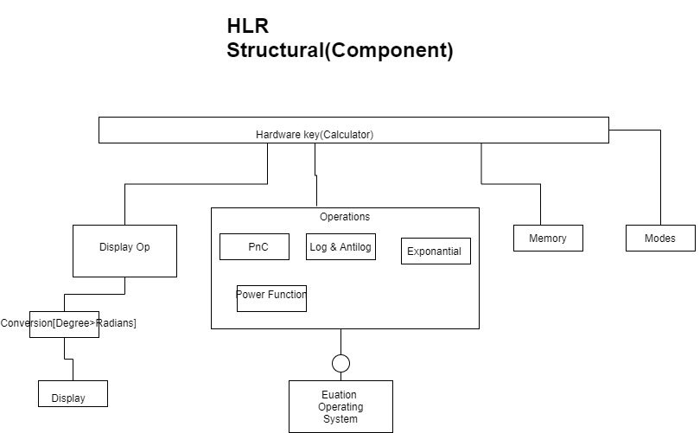

Figure HLR Structural

Low Level Designs:

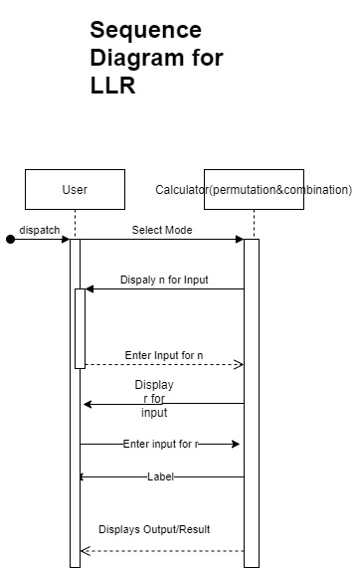

Figure LLR Sequence Diagram

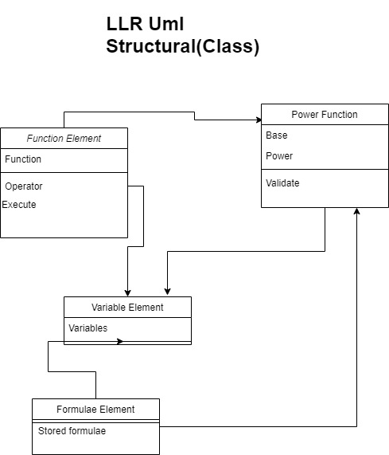

Figure LLR Structural

**Behavioral – Object Diagram**

**Power Function**

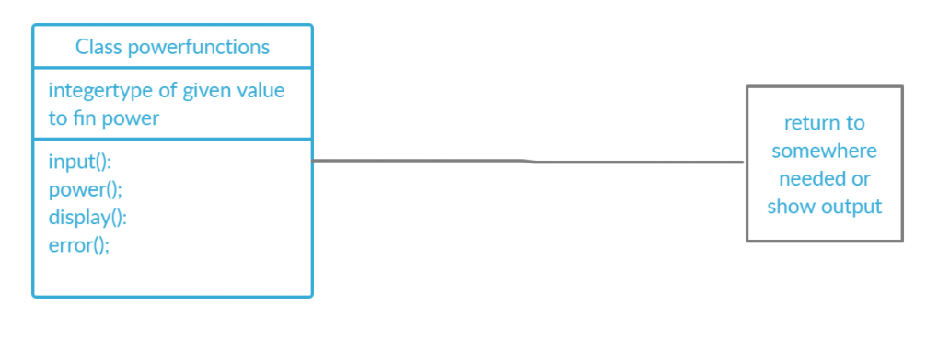

Figure Power function UML

## Test Plan

High-Level and Low-Level test plan:

|  |  |  |  |  |  |
| --- | --- | --- | --- | --- | --- |
| **ID** | **Description** | **Input** | **Expected Output** | **Actual Output** | **Test Type** |
| HLT_1 | When n greater than or equal to r for nPr | n=3 r=2 | 3 | 3 | Scenario |
| HLT_2 | Power fxn F(x)= x^r Where r is greater than equals to 0 | x=2 r=3 | 8 | 8 | Requirement |
| HLT_3 | Conversion of temperature unit | - Stores up to 5 memories. | f | f | Requirement |
| HLT_4 | Conversion of degree to radian | - Show all memories in a first in last out style after every click | degree | radian | radian |
| LLT_1 | When n<r for nPr | n=2 r=3 | Error | Error | Scenario |
| LLT_2 | Finding the square of given number i.e. find power of number will be 2 | 100^2 | 10000 | 10000 | logic based |
| LLT_3 | Finding the power of given number i.e. find power of number will be any number | 2^5 | 32 | 32 | logic based |
| LLT_4 | Finding the power of big number i.e. find power of number which results in digits more than 20 | 3^20 | 3.84*10^9 | 3.84*10^9 | Boundary based |
| LLT_5 | find permutation using the formula | 3,2 | 6 | 6 | logic based |
| LLT_6 | finding permutations of large numbers | 180,179 | Error: large result | Error: large result | Boundary based |
| LLT_7 | Permutation of numbers when n<r | 10,11 | Error | Error | Requirement based |

## **Implementation Summary**

The implementation part of the project consists of the software implementation of the product, Calculator, as documented in the requirements and design section of the life cycle. It consists of various C files in the and header files that link the multiple files. It also consists of the Make file which is used to build run and clean all the multiple files and check for the test cases that are formulated according to the requirement specified.

The source files contain the implementation of the various high-level requirements specified including the following functions:

* + - Arithmetic Operations
    - Trigonometric Operations
    - Roots
    - Log and Antilog functions
    - Permutation and combination
    - Conversion of units
    - Factorial and power functions

### Git Link

<https://github.com/99003721/AppliedSDLC_Calculator_N1>

### Git Dashboard

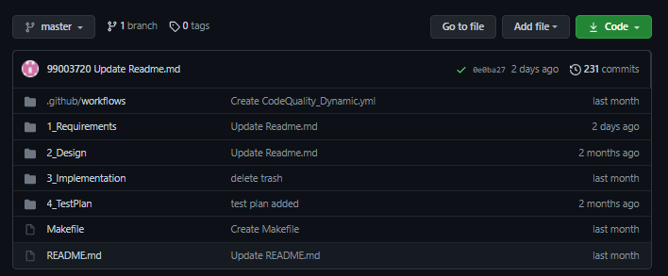

Figure Git dashboard

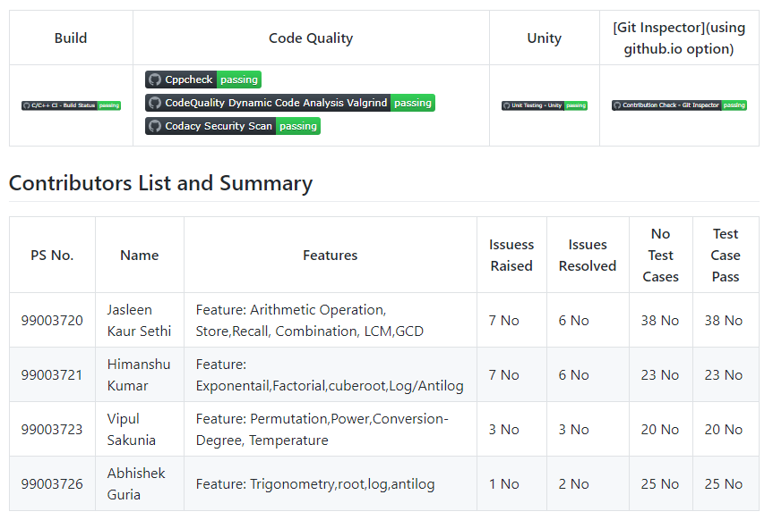

Figure Git Dashboard 1

### Summary

This project started with the research on the various calculators in the market, its age and its features. Then the requirements for our custom calculator was documented in the form of high level and low-level requirements. After the formulation of requirements, the design was made using the UML diagrams for the visual understanding of how the calculator software must be executed. After that, all the features required by the calculator are created in the form of C codes. The codes are then tested with all the possible test cases and error detection and correction is done. All the multiple files along with the headers are then executed and run with the help of a Makefile. Various building, CPP Checks and Unity testing is then done on the codes and badges for these workflows are finally attained.

#### Git inspector summary

#### 

Figure Inspector Summary

#### Build

**Setup done**

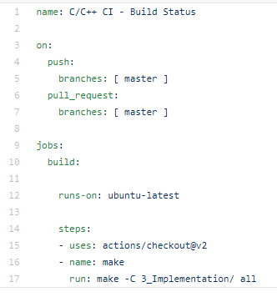

Figure Setup Git

**Outcome**

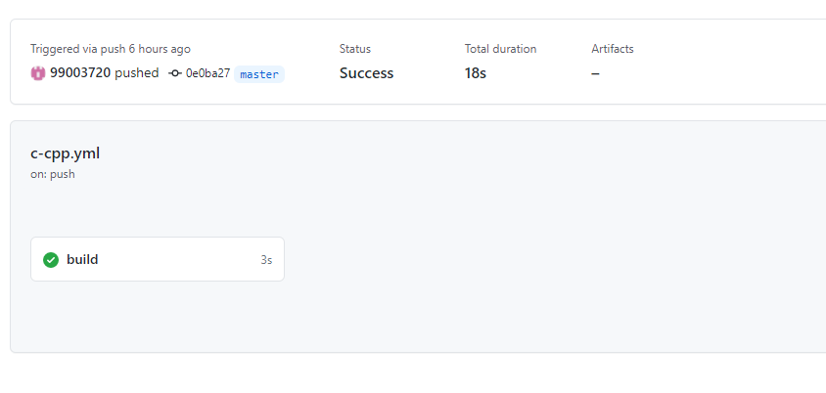

Figure Build

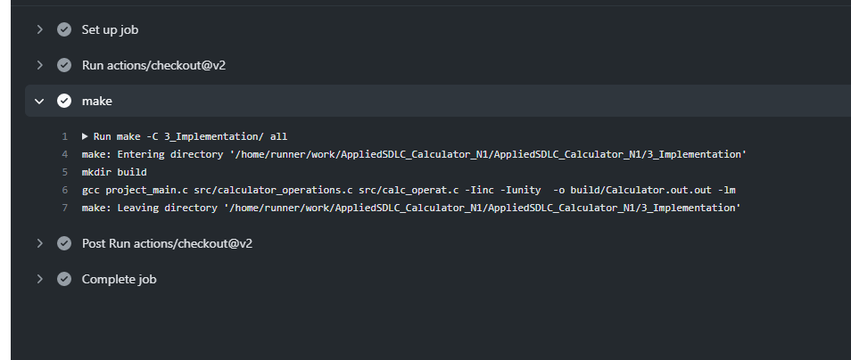

Figure Built Action

#### Code quality and Issues or Bug Tracking

**Setup Alignment**

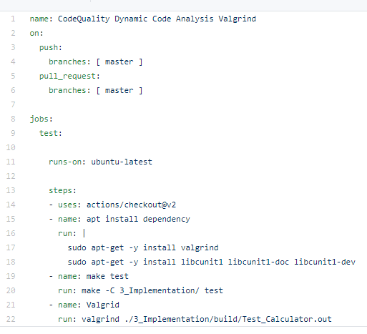

Figure Setup Alignment

**Outcome**

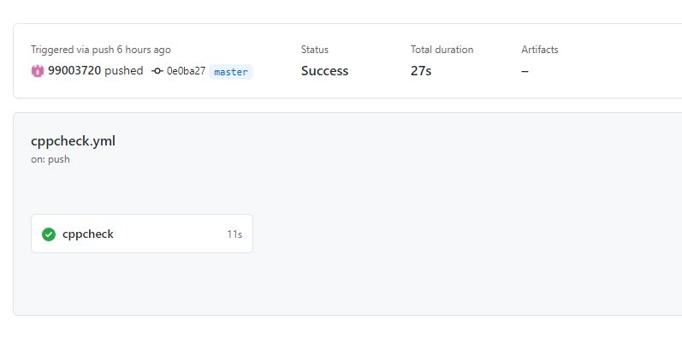

Figure Cpp check

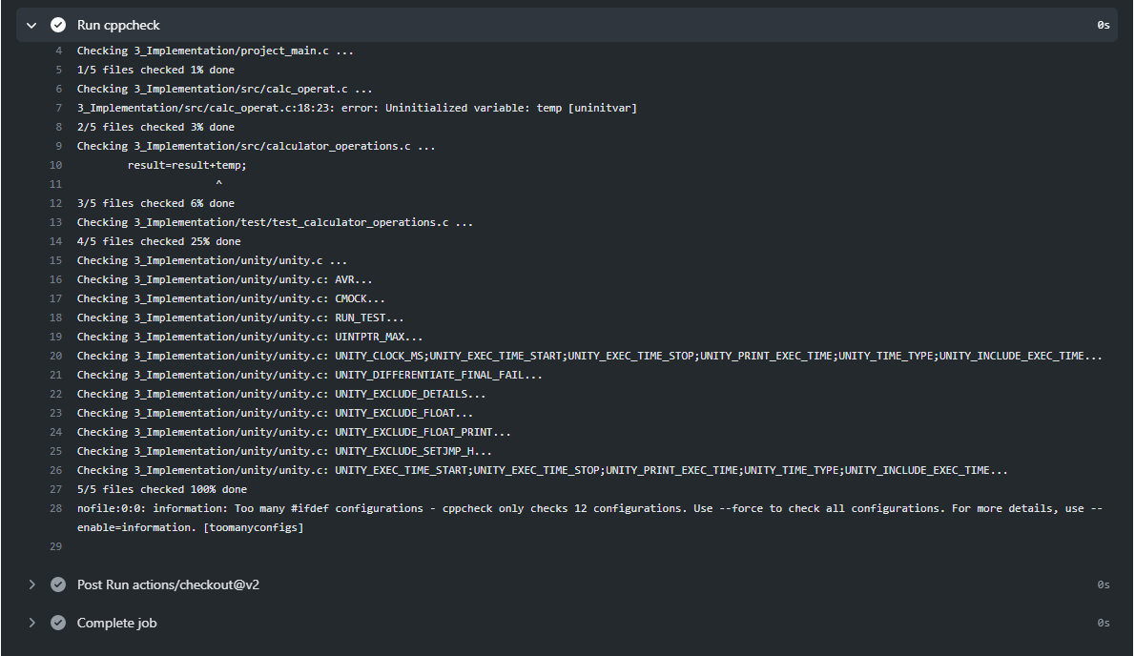

Figure Cpp Run Check

**Issues**

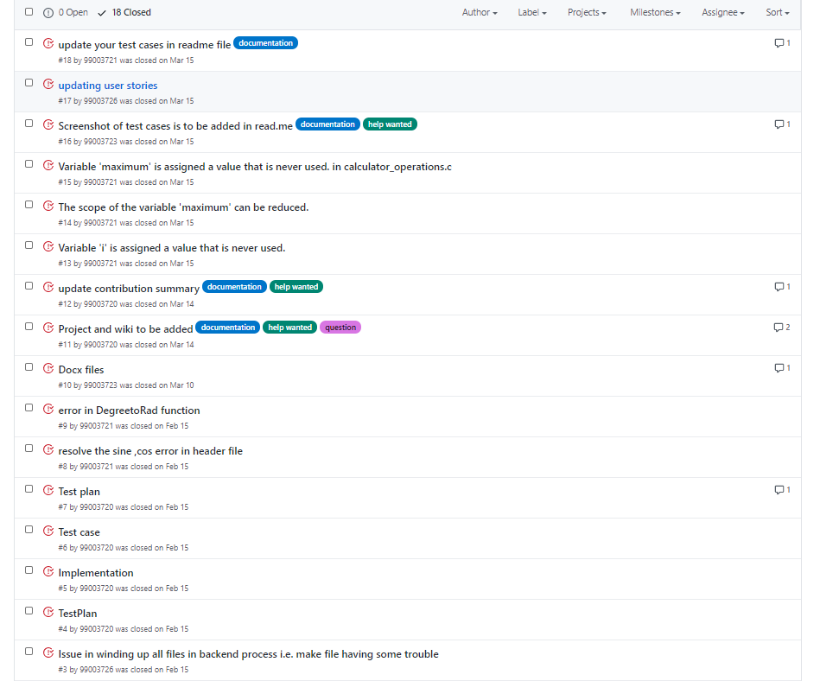

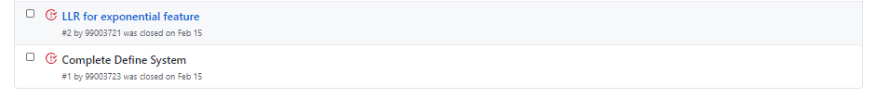

Figure Issues

#### Unit Testing

**Setup Alignment**

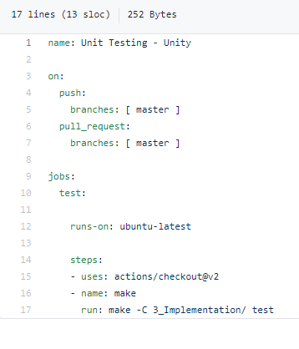

Figure Unit Testing setup

**Outcome**

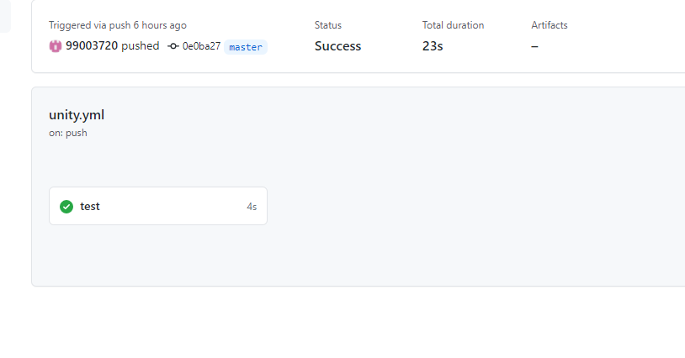

Figure Unit testing Outcome

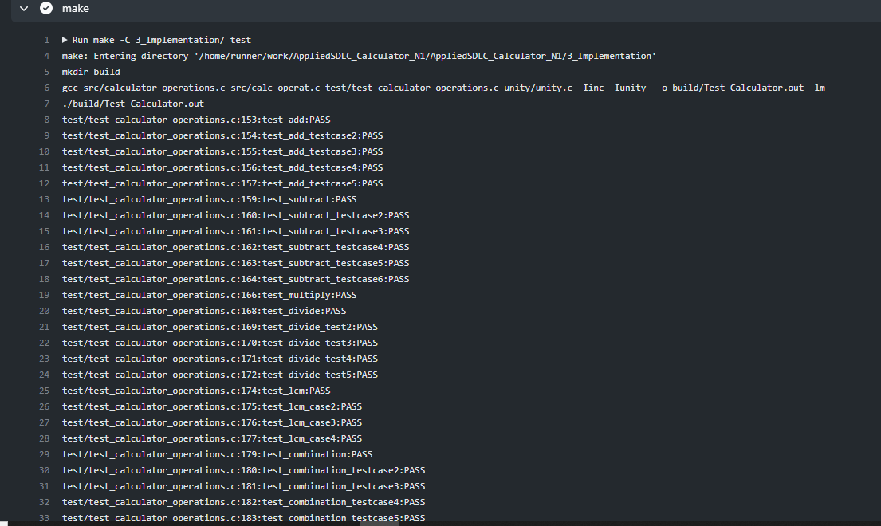

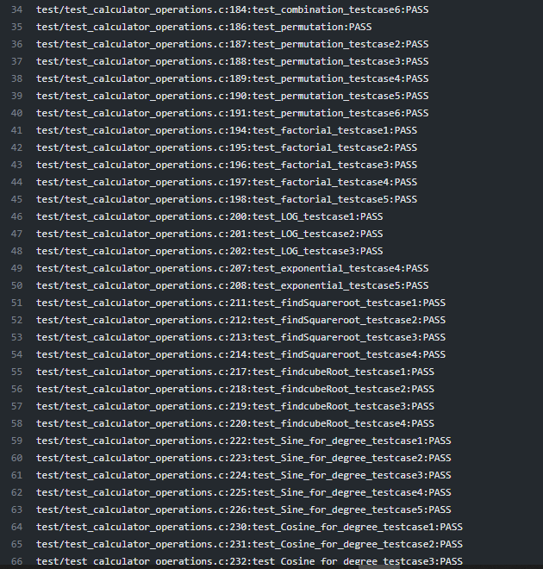

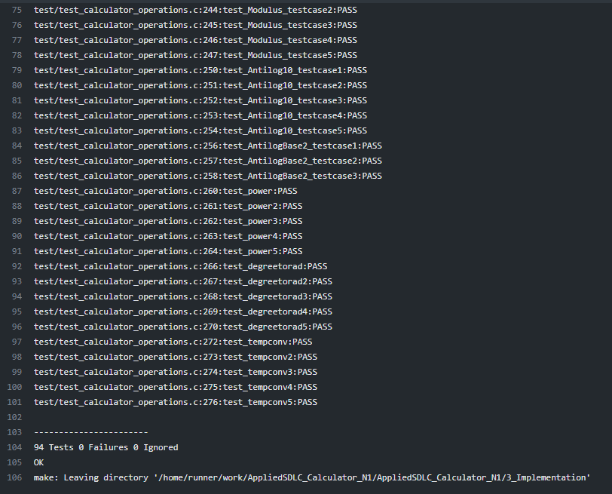

Figure Unit Testing Outcome2

## **Individual Contribution & Highlights**

The features implemented by me are:

Permutation and Combination

* + - Requirements and design for the permutation.
    - Implemented code for permutation of two positive numbers

Power

* + - Requirements and design for the power functions
    - Implemented code for power of two positive numbers

Conversion of Units

* Requirements and design for conversion of temperature and degree.
* The low-level design for the operations
* Various test cases for the operations including all kinds of requirements.

### Summary

* Through this project, I learnt about team work and managing the team. Communication between the team members was the most essential part of working in a team so as to execute and complete all the requirements in the given deadline.
* I improved my C programming coding skills with number of different functions implemented by me and my team members.
* I improved my leadership skills by ownership and accountability of work done.

### Challenges faced and how were they overcome

1. Running the make file as its resolved by defining its correct path (.out for Linux and -lm for math functions)
2. Synchronizing the VS code to GitHub, colleague help to resolve the issue
3. Making the function call in correct path
4. Open git log while committing, thus went to GitHub desktop and pulled origin and then pushed origin.
5. Test case code for the boundary problem. Added code with the help of internet

### Future Scope

Every project can be well executed and properly defined when it is designed and deployed as per the Software Development Life Cycle.

# Python [Individual]

## Module

The modules linked to the mini project is Python.

### Topic and Subtopics

**Python Programming**

* + - Strings
    - Loops
    - Exception Handling
    - Classes and Objects
    - Hacker Rank- Python Learning
    - Solo Learn – Python
    - Pytest

**Tools**

* PyCharm
* Notepad++
* VScode
* PEP8

## Objectives & Requirements

Problem Statement was to find the five input words in the given source file i.e., .txt file and give the output in a new file by creating it. The output must contain one word before and after the input word (desired word).

## **High Level requirement analysis**

|  |  |  |  |
| --- | --- | --- | --- |
| ID | Requirements | Description | Status |
| **HL_1** | Searching Word | Search the word from the text file given by the user. | Implemented |
| **HL_2** | Writing | Write the words after and before of the searched word in new text file. | Implemented |
| **HL_3** | Extracting user defined data | Write required data in the text file. | Implemented |

## **Low Level requirement analysis**

|  |  |  |  |
| --- | --- | --- | --- |
| **ID** | **Requirements** | **Description** | **Status** |
| **LL_1** | Search Word | The user inputs the word to be searched through the text file. | Implemented |
| **LL_2** | Searching word in every line of the text file. | The data to be searched is defined by the user and then searched throughout the entire text file. | Implemented |
| **LL_3** | Writing the data into new text file. | Data given as an input by the user is searches in every line and the word after and before is extracted too and then added in a new text file along the searched word. | Implemented |

## Code and Output

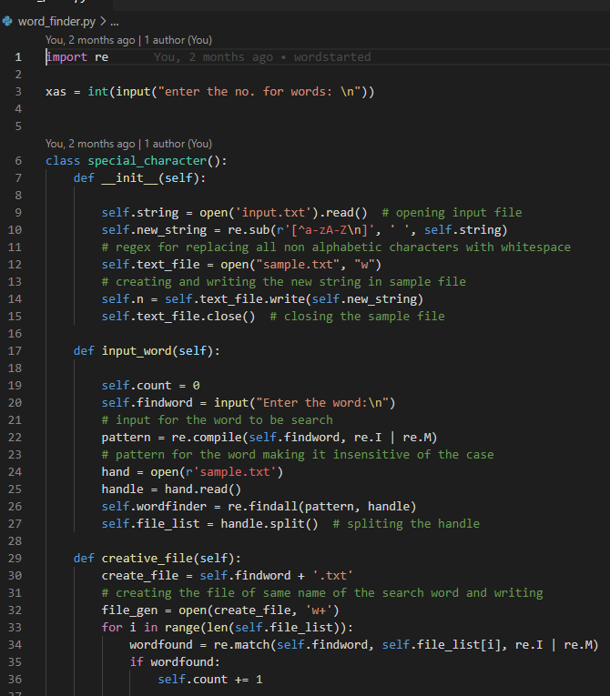

Figure Code Python

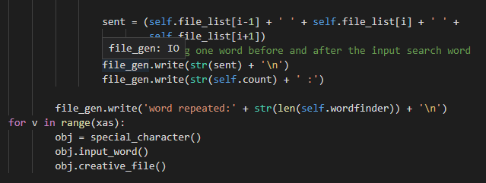

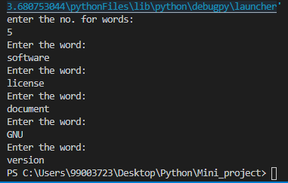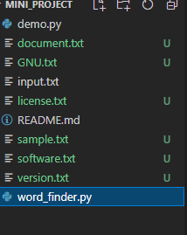

Figure Output Python 1

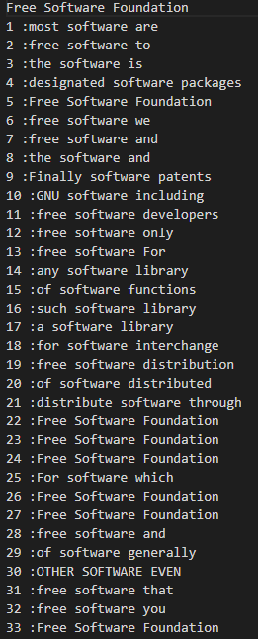

Figure Output Python 2

## Test Plan

|  |  |  |  |
| --- | --- | --- | --- |
| ID | Description | Input | Output |
| T_01 | Should get entered word output as a txt file and number of repetitions | software | 35 |
| T_02 | Should ask the user to enter the number of inputs | Run the program | Enter the no. of words |

### Git Link

<https://github.com/99003723/Mini_project>

### Git Dashboard

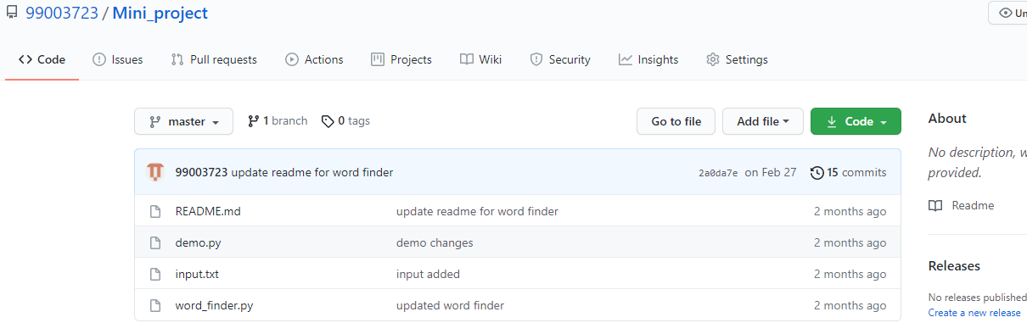

Figure Git dashboard Python

### Summary

The program asks the user to input the number of words, he/she wants to search. The output is provided to the user as a txt file.

I learned to work in different code editors like pycharm and VScode and how to build and execute a program by constructing classes and structures of code. Different test methods to check the quality of code was implemented to get a standardized finish according to the industry levels.

### Challenges faced and how were they overcome

* Executing the code using class structure was confusing but with project work it got cleared.
* Coding in different editors was challenging at first, but as the work progressed I achieved a flow to approach the problem. Applying SDLC also helped to get a clear idea about the project.

# Embedded-C [ Team]

## Module

Module linked to the BCM features is Embedded C.

### Topic and Subtopics

* Make Start Up file
* Linker Script
* Debugging techniques
* Driver library creation & HAL library
* Stm32cube-IDE

## Objectives & Requirements

* Implementation of BCM Features in STM32cube-IDE and dump in to microcontroller(ARM-cortex-M4) and verify its functionality.
  1. Hood release control
  2. Exterior lighting
  3. Automatic Wiper control
  4. Internal lighting

## Design and Test Plan:

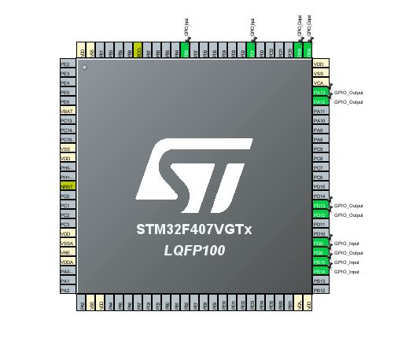

Figure Pin Configuration

Above mentioned features are implemented in the code snippet given below:

1. Hood release control

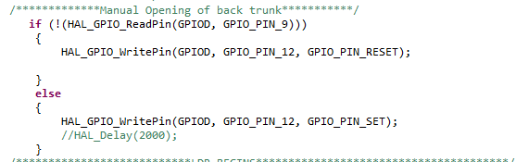

Figure Code Snippet for Hatch Control

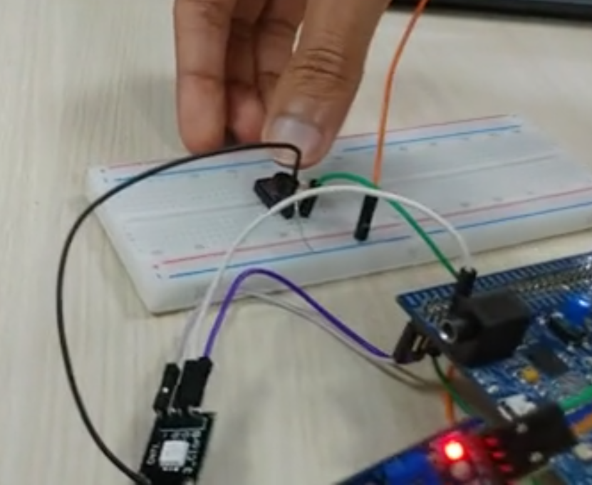

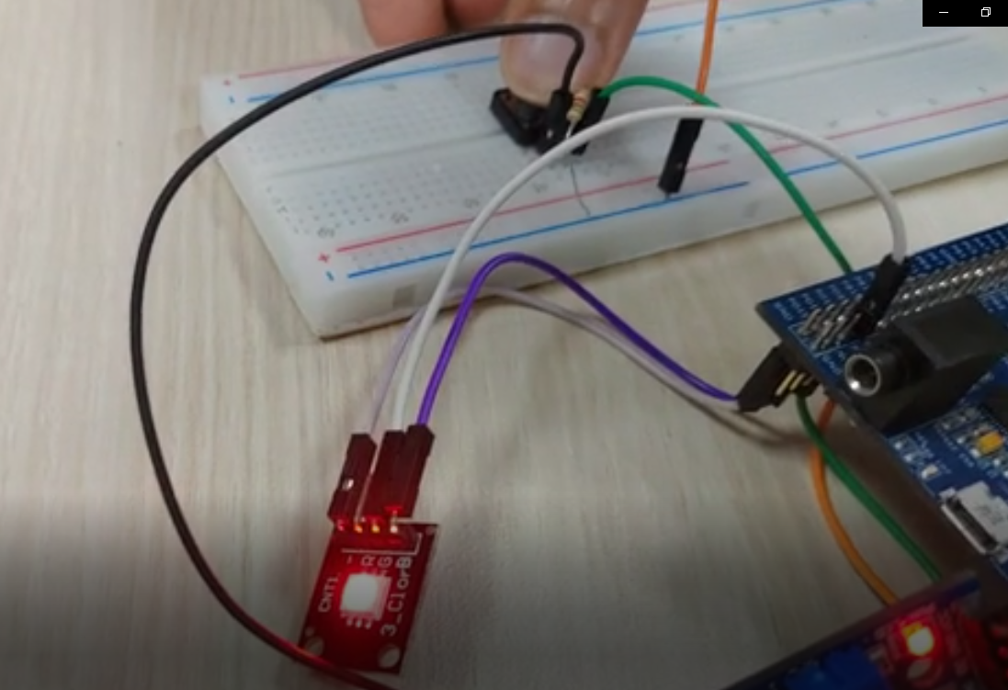

Figure Microcontroller implementation of Hood control from switch

1. Exterior Lighting Using LDR

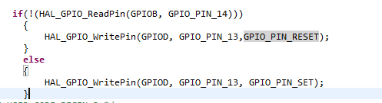

Figure Code snippet for Exterior Lighting

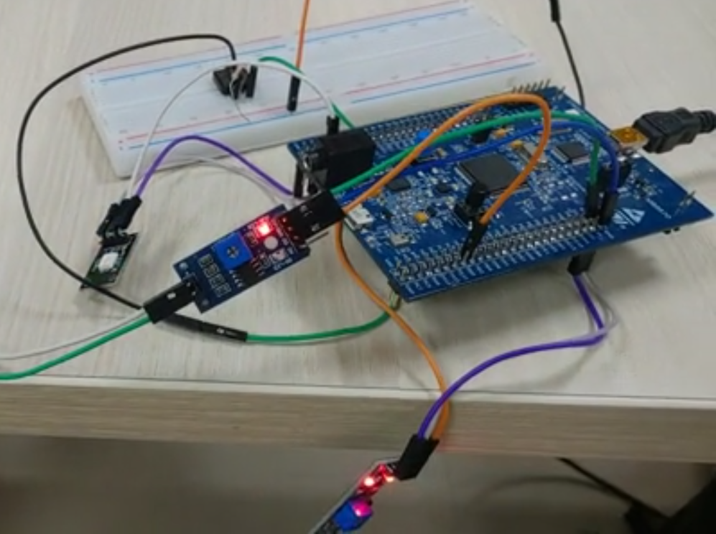

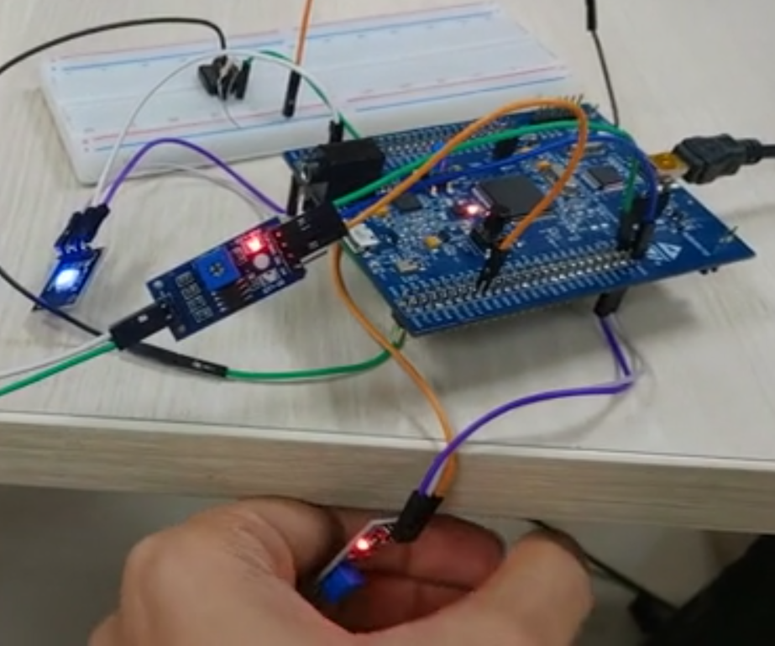

Figure MC implementation of Exterior lights using LDR sensor

1. Interior light switching using switch

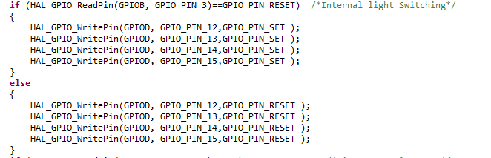

Figure Code snippet for Interior lighting

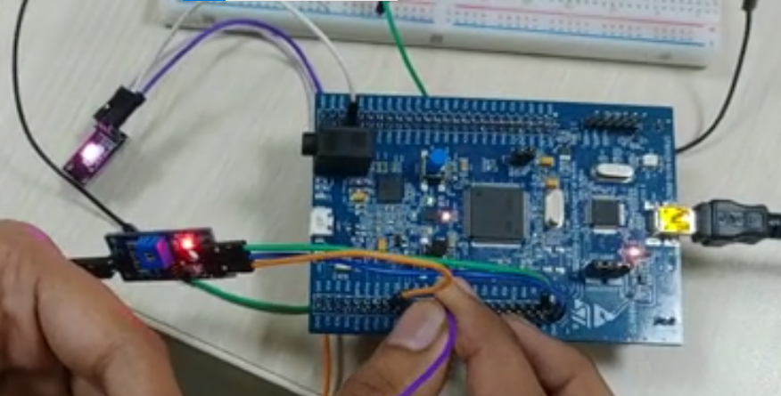

Figure Image of the microcontroller implementation of interior lighting (Pink Light)

1. Automatic wiper control

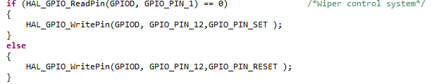

Figure Code snippet for Wiper control

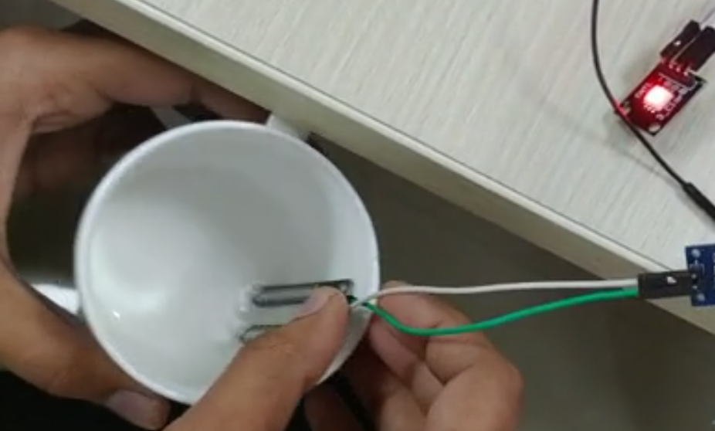

Figure Microcontroller implementation of Wiper Control

## Implementation Summary

Connected the STM32 Board and made some configuration so that HAL libraries are added in to the micro controller and did the PIN configuration according to the features and wrote the program accordingly and verified it in the micro controller.

## Individual Contribution & Highlights

Code contribution in final code – Designing the Hood release & Exterior lighting.

### Summary

Outcomes:

1. STM32f407 discovery board programming.
2. Programming the features BCM module: Hood release and exterior lights using LDR sensor.

### Challenges faced and how were they overcome

|  |  |
| --- | --- |
| Challenges | Resolution |
| Creation of drivers | HAL Driver and later created own driver also. |
| Integration of model | Using IDE |

# MBSE [Team]

To implement different Body Control Module (BCM) feature present in a car using MATLAB and Simulink modelling. To test the respective feature and whole integrated system using Manual testing and Automated testing.

Here GMC Sierra truck is taken as a reference to build the model.

|  |  |
| --- | --- |
| Sr. no. | Module |
|  | MATLAB & Simulink |
|  | Logical operations. |
|  | State flow |

BCM and comfort module should have following features:

1. Engine status (key position)
2. Seat belt reminder
3. Power outlet
4. Gear control
5. Steering control
6. Exterior lighting
7. Interior lighting
8. Cruise control system
9. Tire pressure management system
10. Wiper control
11. Power window
12. Hood Release

## Objectives & Requirements

High Level requirements for Engine status, Power Outlet, Gear Control, Seat Belt reminder:

|  |  |
| --- | --- |
| **ID** | **Requirements** |
| HLR_ES_1 | Ignition Key position |
| HLR_ES_2 | Engine state output through lamp with different colors. |
| HLR_PO_1 | Engine Status |
| HLR_PO_2 | Power Outlet Push button to switch. |
| HLR_PO_3 | Power Outlet display for output. |
| HLR_GC_1 | Engine Status |
| HLR_GC_2 | Radio button to change the gear position. |
| HLR_GC_3 | Gear display for output. |
| HLR_SBR_1 | Engine Status |
| HLR_SBR_2 | Toggle Switch to input the position of seat belt. |
| HLR_SBR_3 | Should remind the driver to fasten seat belt through bickering lamp. |
| HLR_SBR_4 | Gear Mode Status. |

Low Level requirements:

|  |  |
| --- | --- |
| **ID** | **Requirements** |
| LLR_ES_1 | 4 positions of key ignition for engine status OFF, ACC, ON/RUN, START |
| LLR _ES_2 | Key position different outputs for different features so as to integrate the model accordingly. |
| LLR _PO_1 | Outlet should be OFF if engine status is OFF. |
| LLR _PO_2 | Outlet should be ON if engine status is ACC. |
| LLR _PO_3 | Outlet should be ON if engine status is ON/RUN. |
| LLR _PO_4 | Outlet should be ON if engine status is START. |
| LLR _GC_1 | For active gear control Engine Status should be at START mode. |
| LLR _GC_2 | 4 gear positions Park, Neutral, Drive, Reverse. |
| LLR _GC_3 | Gear output for display in dashboard. |
| LLR _GC_4 | Gear output for Seat belt reminder. |
| LLR _GC_5 | Gear transition through state flow from the input of gear mode from the user. |
| LLR _SBR_1 | Engine status should be in ACC, ON/RUN or START for SBR to activate. |
| LLR _SBR_2 | Buckle sensor should give output as a reminder to the user through display if seat belt not buckled. |
| LLR _SBR_3 | Buckle sensor should stop reminding when seat buckle is closed. |
| LLR _SBR_4 | SBR should be activated when the gear is in any position other than park. |
| LLR _SBR_5 | Gear output for input Seat belt reminder. |
| LLR _SBR_6 | Seat belt reminder implementations through state flow. |

## Design

High Level Design:

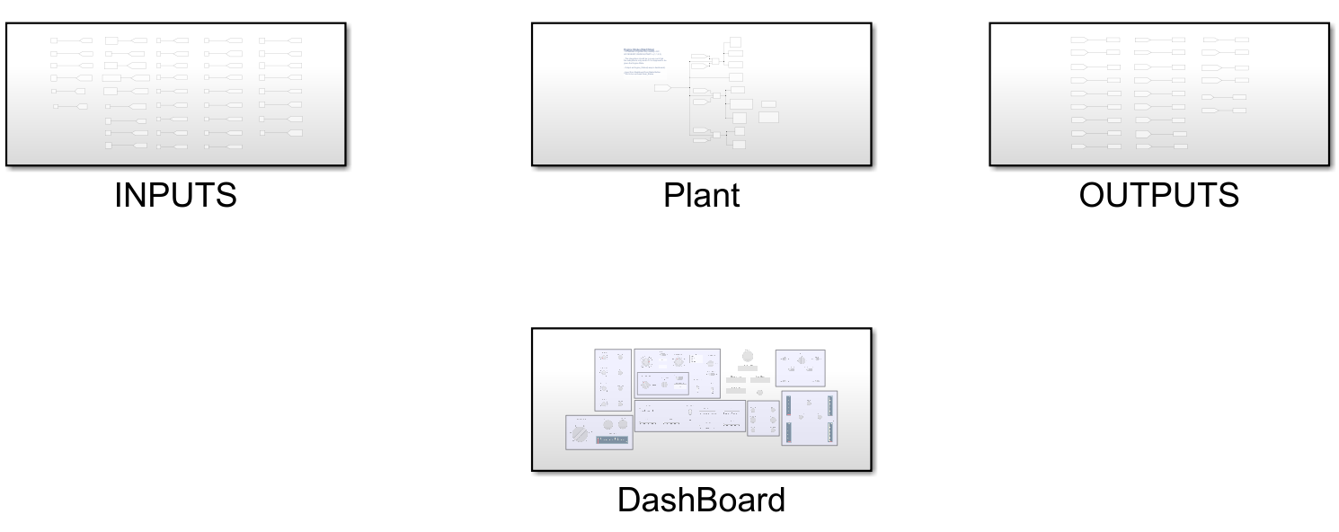

Figure High Level MBSE Design

Inputs:

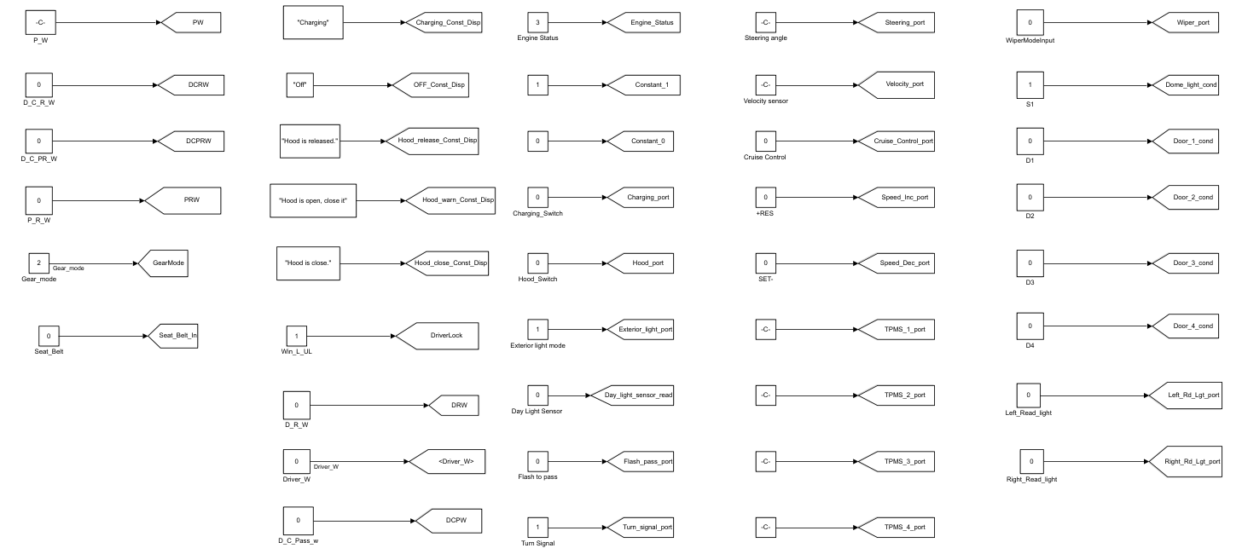

Figure MBSE Input

Outputs:

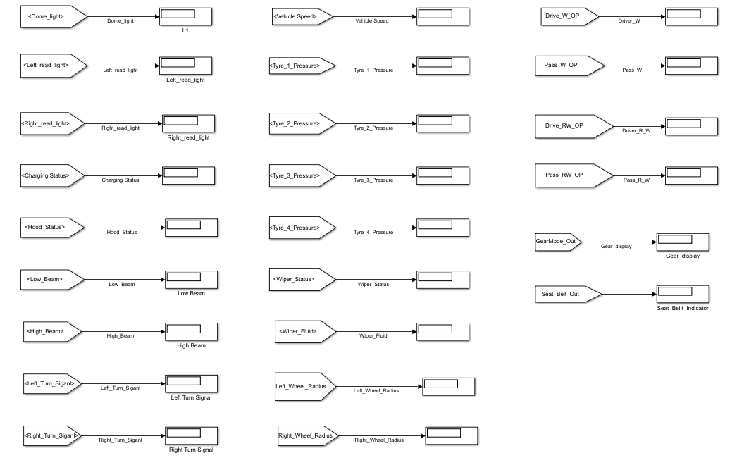

Figure MBSE Output

Dashboard:

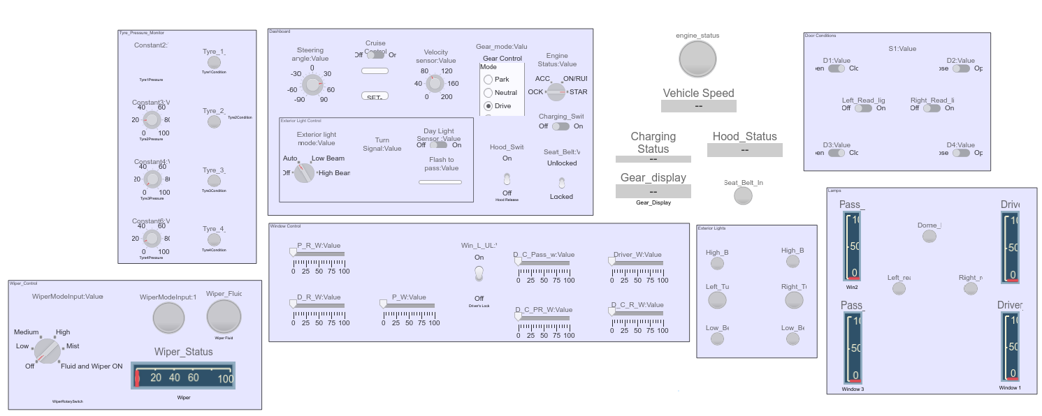

Figure Dashboard

Plant:

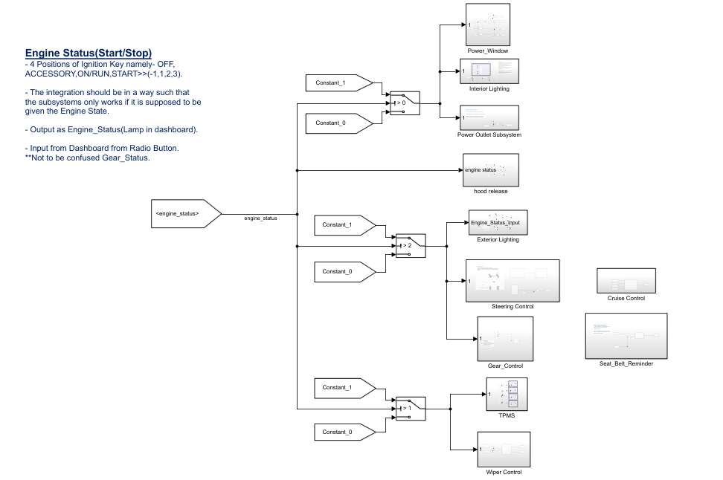

Figure MBSE Plant

Low Level Design for Individual System:

* 1. Engine Status/Key Ignition Position:

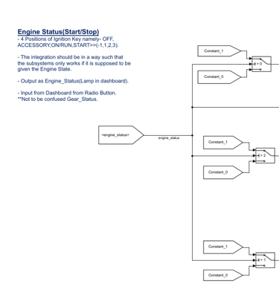

Figure Engine Status/Key Ignition

* 1. Power Outlet:

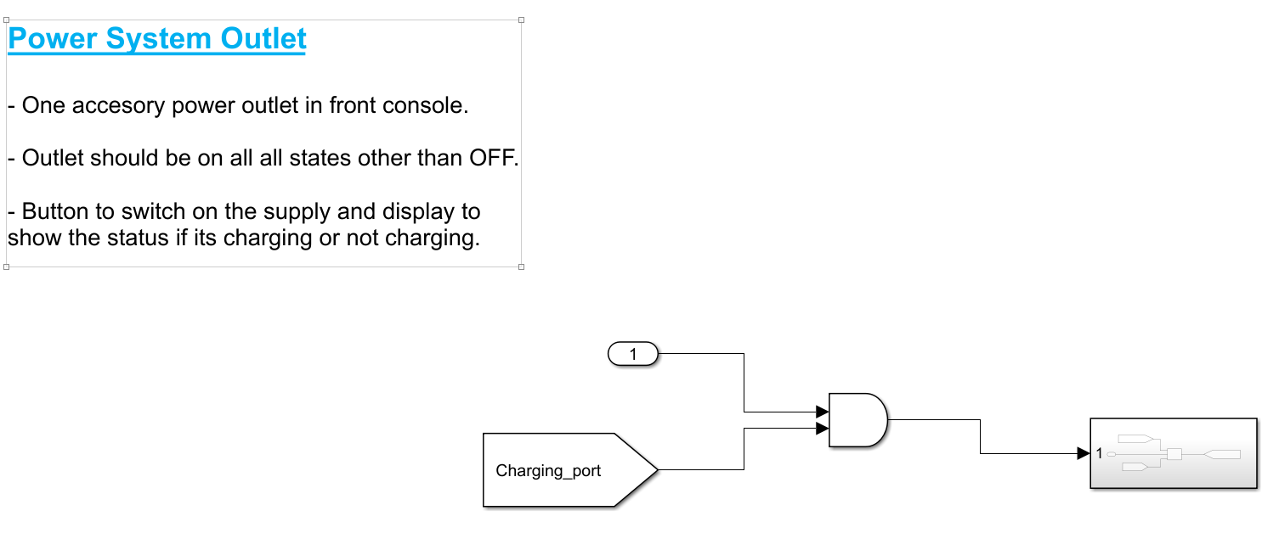

Figure Power Outlet

* 1. Gear Control:

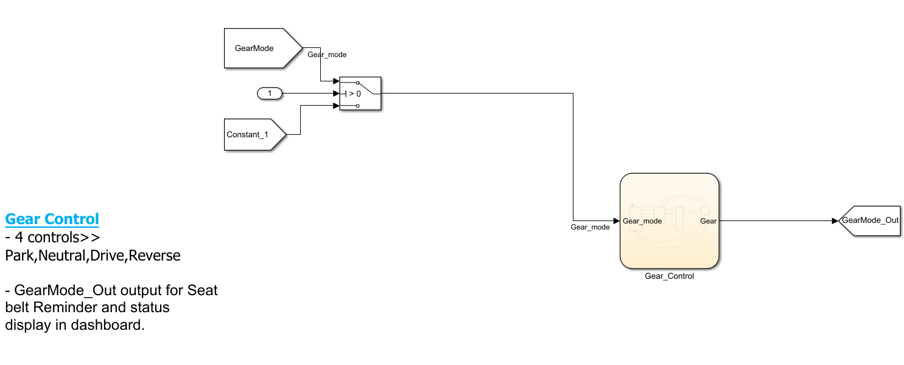

Figure Gear Control

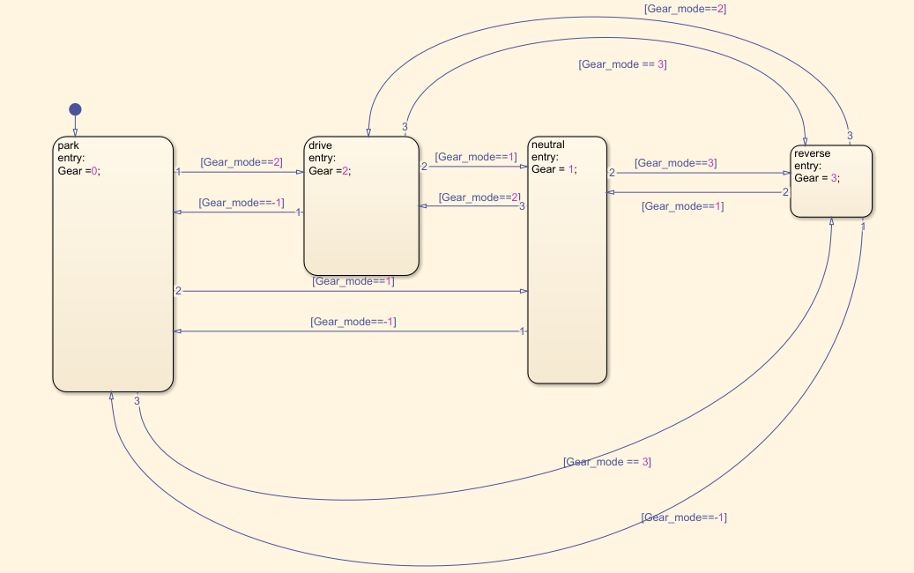

Figure Gear Control State flow

Gear positions Output:

* Park= 0
* Neutral= 1
* Drive= 2
* Reverse= 3
  1. Seat Belt Reminder:

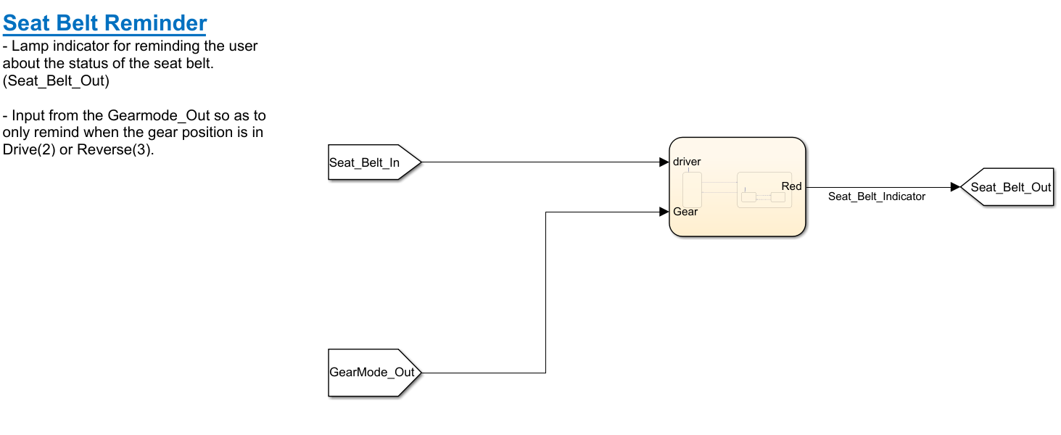

Figure Seat Belt reminder MBSE

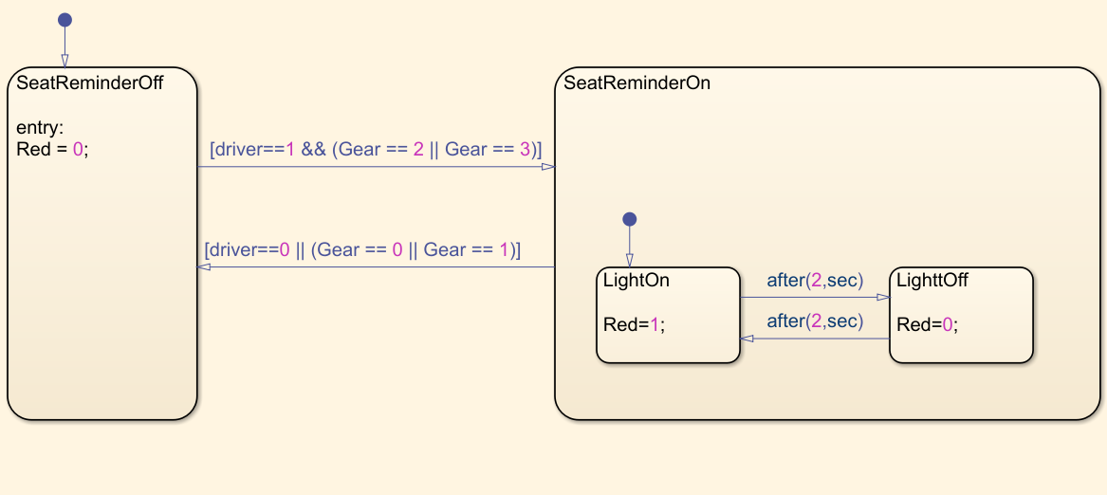

Figure SBR Sate flow Implementation MBSE

## Test Plan

|  |  |  |
| --- | --- | --- |
| ID | Input | Output |
| ES_1 | Change knob position from STOP to START | Green light in lamp |
| PO_1 | Engine status in ACC and charging mode slider on | Charging on display |
| PO_2 | Engine status in START and charging mode slider OFF | Not Charging |
| GC_1 | In Park Position | 1 in Gear display |
| GC_2 | Engine in Start position and gear In Neutral Position | 2 |
| GC_3 | In Reverse Position | 3 |
| SBR_1 | Engine in START mode  Gear Position in Park  and seat belt toggle in locked | No blinking of lamp |
| SBR_2 | Engine START  Gear at Drive  Seat belt unlocked | Blinking of lamp |

## Implementation Output

* The figure below shows the following outputs:
  + 1. Engine status is shown which is in ON/RUN position.
    2. Charging Port Is ON.
    3. Seat belt indicator is OFF as seat belt is in locked position.
    4. Gear position is neutral position i.e., Gear display output as 1.

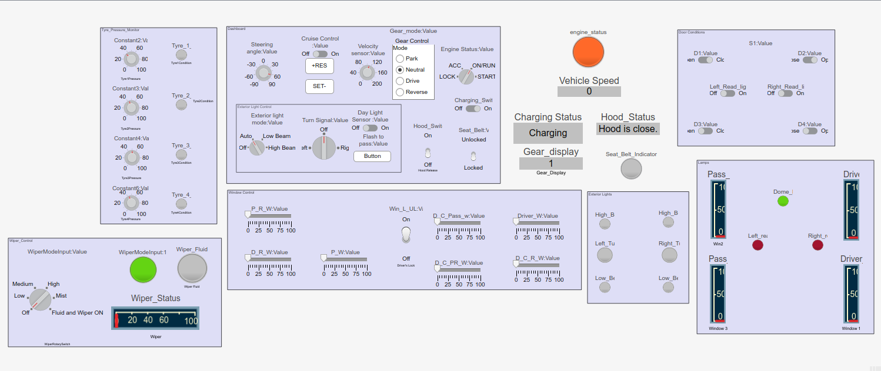

Figure Output for Manual Implementation 1

* The figure below shows the following outputs:

1. Engine status is shown which is in START position.
2. Charging Port Is ON.
3. Seat belt indicator is ON as seat belt is in unlocked position.
4. Gear position is Drive position i.e., Gear display output as 2.

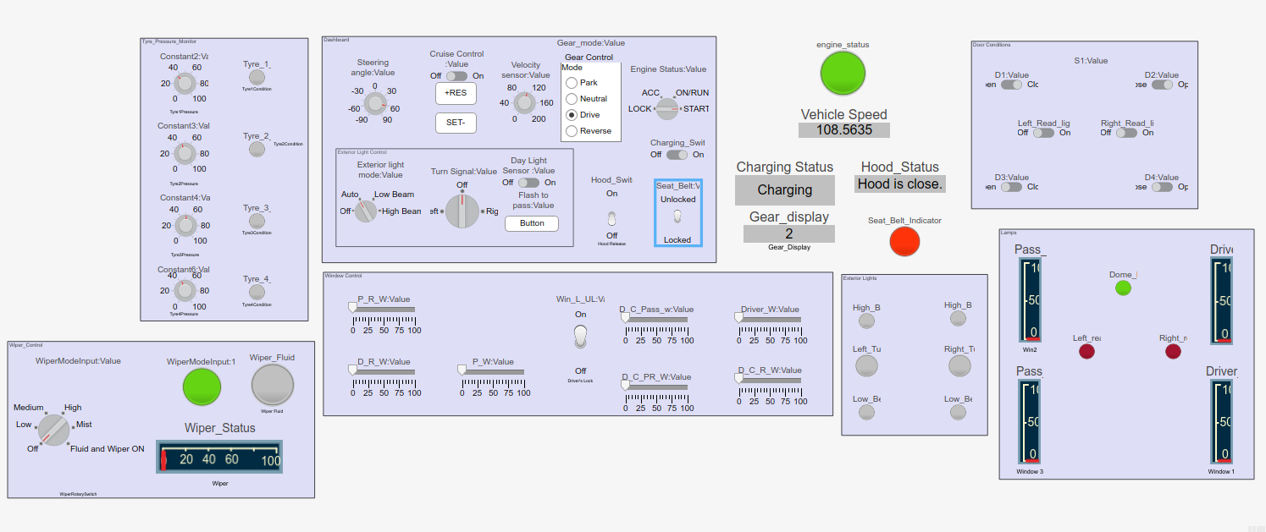

Figure Output for Manual Implementation 2

## Implementation Summary

All features are integrated in such a way that they work only when corresponding Engine status is ON. Designing of the BCM features i.e. Engine status, Power Outlet, Gear Control and Seat belt reminder using MATLAB and Simulink. Designing of the manual testing model and automated testing models. Integration and manual testing was done.

### Summary

We went through an extensive research about the BCM features present in GMC Sierra. We tried to build the models in Simulink with the help of state flow. Proper conventions were maintained while building the models. We also did manual as well as testing of our individual models. Integration testing was also performed combining all the features of the group members.

## Individual Contribution & Highlights

|  |  |
| --- | --- |
| **Role in team** | **Description** |
| Subsystem designing | Designing of the subsystems – Engine Status, Power Outlet, Gear Control, Seat belt reminder. |
| Gathering requirement | Requirements and test cases. |
| Integration | Integration of subsystems input & outputs. |

### Challenges faced and how were they overcome

|  |  |
| --- | --- |
| Challenges | Resolution |
| Requirement | Using 2020-gmc-Sierra-Owners-Manual |
| Integration of whole model | Was overcome with the help of each team members clear idea of implementation from the start. |

# Automotive systems and overview-MBD Evolved[Team]

The automotive central body control module (BCM) is a processor-based power distribution center that supervises and controls functions related to the car body such as lights, windows, security, door locks and access control, and various comfort controls. The features implemented here are Power window, Tire Pressure Management System, Cruise Control, Exterior Lights and seatbelt reminder. HIL testing for TPMS and exterior lights.

## Features

Seat Belt Reminder:

Seat Belt Reminder (SBR) sensor mat detects occupants in passenger and rear seats. This information is then used by a seat belt reminder system in the vehicle to trigger a warning light and/or an audible chime reminding unbuckled seat occupants to fasten their seat belts. Research studies indicate that the risk of dying in a crash could be reduced by about 60% by using the seat belt and by more, when belts and air bags are combined (WHO 2004). While most drivers wear seat belts in the fronts of cars, a significant proportion involved in crashes are unrestrained, even in countries with highest seat belt use.

## Objectives & Requirements

The reasons drivers indicate most often as to why they do not use a seat belt include short trips, forgetfulness, in a rush, and discomfort. Basic seat belt reminder system –The reminder or warning system can consist of a visual signal (a blinking icon or text display) or an acoustic signal of varying pitch. A combination of both signal types is often used for the front seat belts. A warning light and a tone activated immediately after the vehicle is started and continues if a driver is not belted, with the light persisting for at least 60 seconds before getting solid indication.

## High Level Requirements:

|  |  |
| --- | --- |
| ID | Requirements |
| HLR_SBR_1 | Should remind the driver to fasten seat belt through display. |
| HLR_SBR_2 | Engine Status. |
| HLR_SBR_3 | Seat Sensor and Buckle Sensor |
| HLR_SBR_4 | Gear Mode Status. |

## Low Level Requirements:

|  |  |
| --- | --- |
| ID | Requirements |
| LLR_ SBR_1 | Seat Sensor should be activated when driver seats upon it. |
| LLR_ SBR_2 | Buckle sensor should give output as a reminder to the user through display and chime if seat belt not buckled. |
| LLR_ SBR_3 | Buckle sensor should stop reminding when seat buckle is closed. |
| LLR_ SBR_4 | SBR should be activated when the gear is in any position other than park. |
| LLR_ SBR_5 | Engine status should be in ACC, ON/RUN or START for SBR to activate. |

## Design

High level:

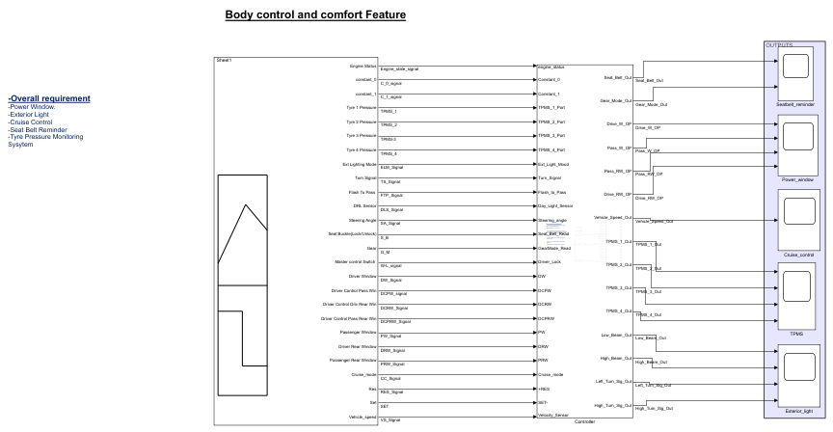

Figure High level Design

Low Level:

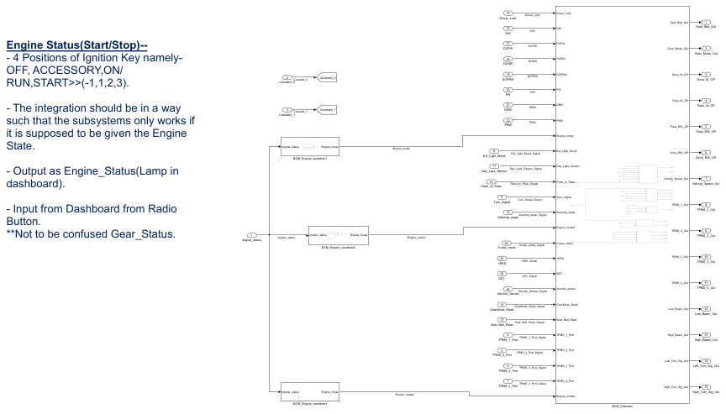

Figure Low Level design

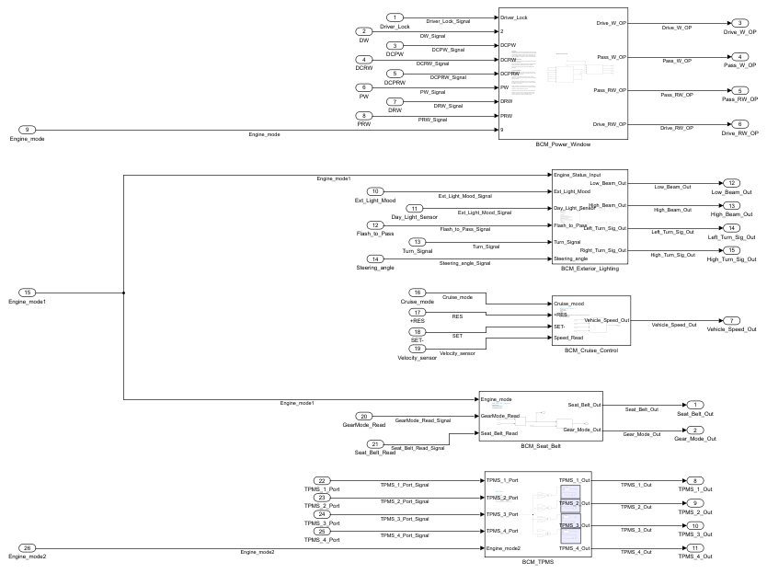

Figure Evolved Plant

## Feature Model

Seat Belt Reminder:

Passenger seat not considered.

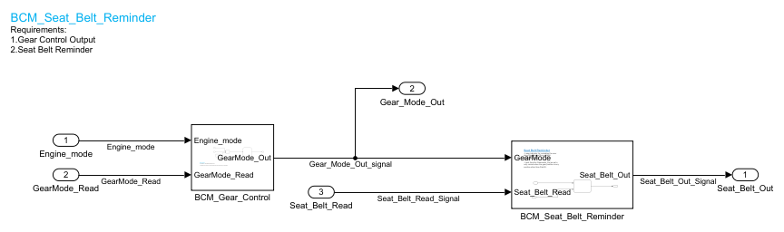

Figure Seat Belt reminder model

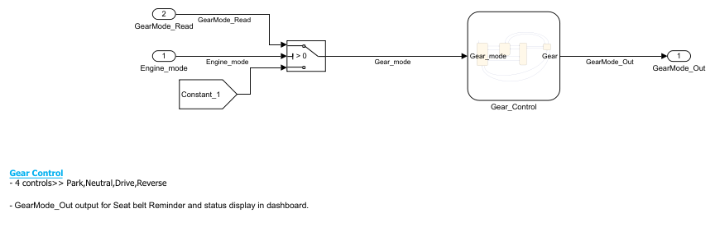

Figure Gear Control for Input to SBR

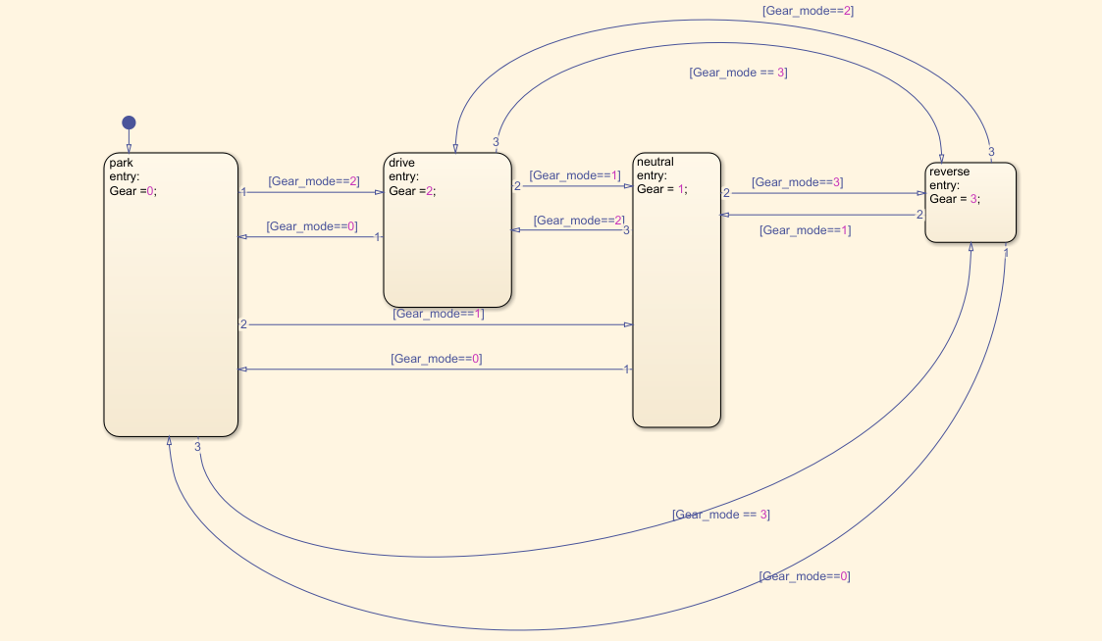

Figure Gear Implementation State Flow

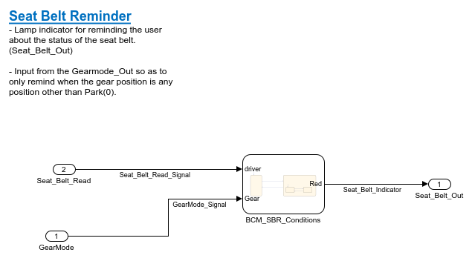

Figure SBR low level model

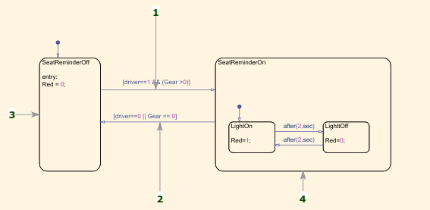

Figure State flow for SBR

Algorithm:

* Seat Belt Reminder

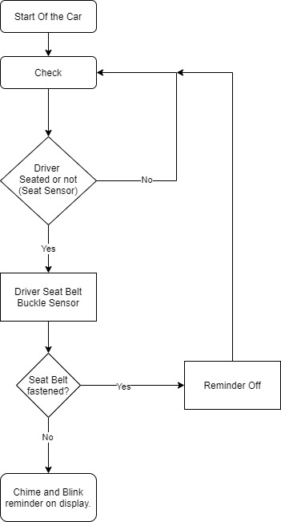

Figure Algorithm SBR

SWOT Analysis:

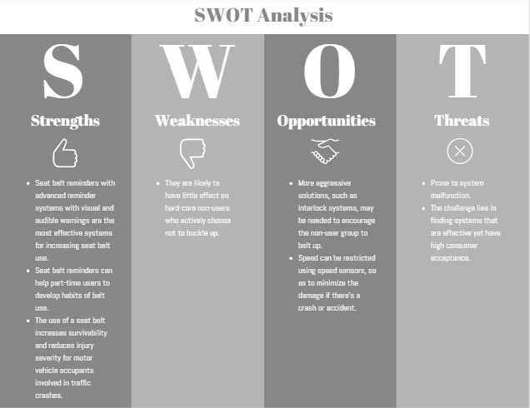

Figure SWOT for SBR

## Test Plan

Refer Excel sheet for the test plan: [Reference link for test cases excel sheet](https://lnttsgroup.sharepoint.com/:x:/r/sites/GEA/Global%20Engineering%20Academy/GENESIS%20%20Jan%202020%20Submission/Submission/BANGALORE/2002BLRGT04/Project/Team-3/MBSE_Evolved/4.Test%20Results/BCM_TPMS.xlsx?d=w875806b2fe07472b91088f22297a12e0&csf=1&web=1&e=XBPnDi)

### HIL Testing for TPMS and Exterior Lights

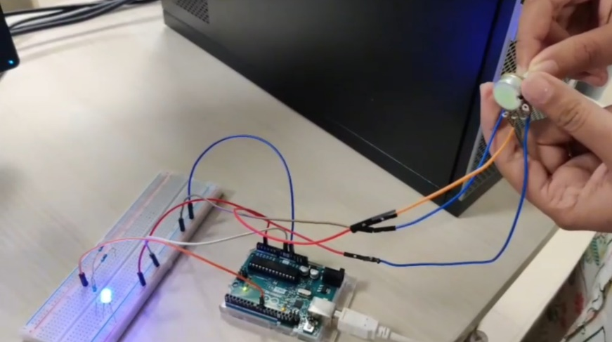

Figure HIL testing for TPMS

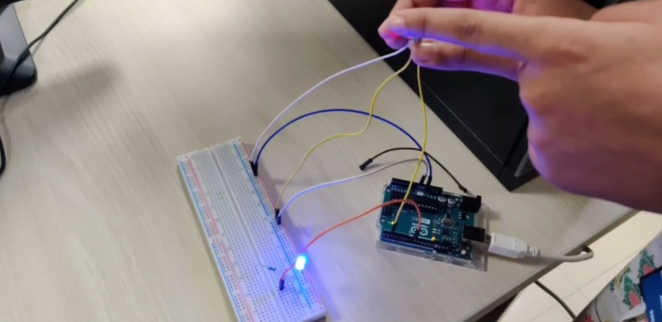

Figure HIL testing for Exterior Lights

## Implementation

## Model Advisor Report

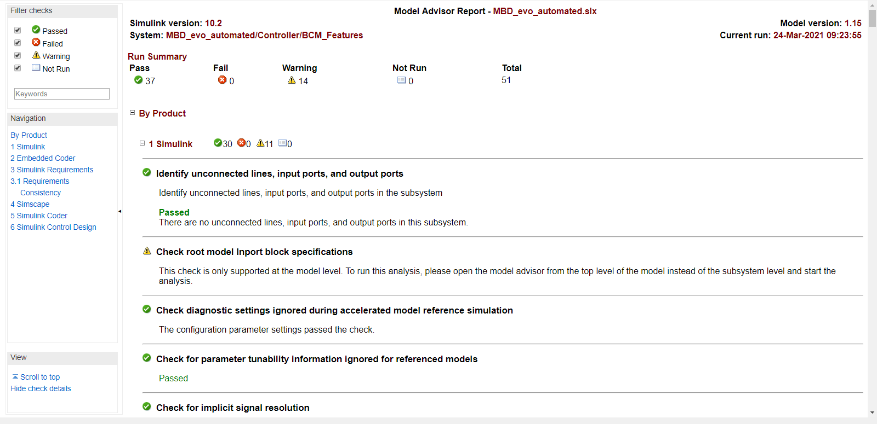

Figure Model advisor for whole model

## MCDC Report

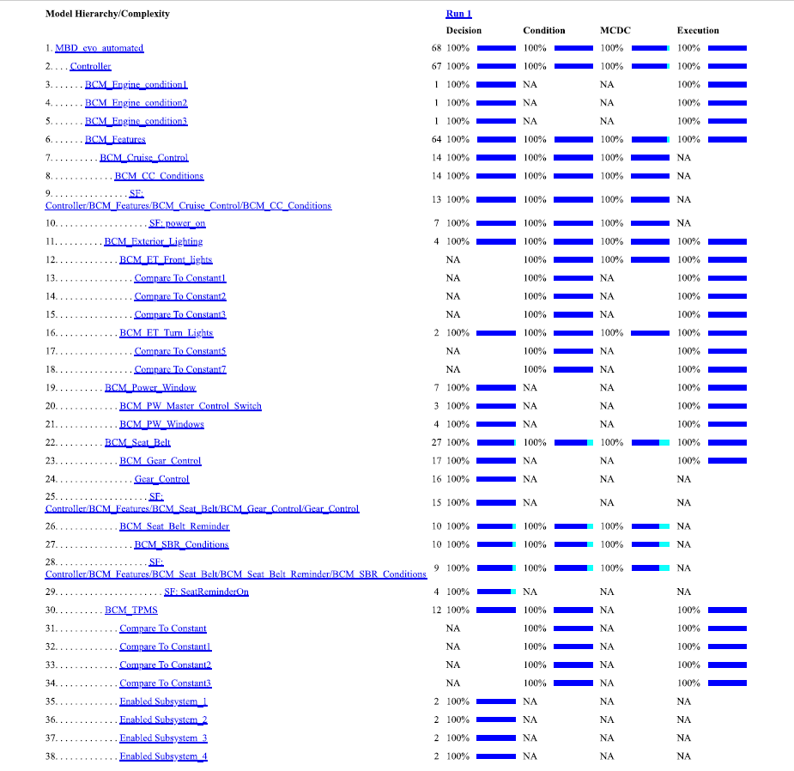

Figure MCDC report

## Automated Output Result

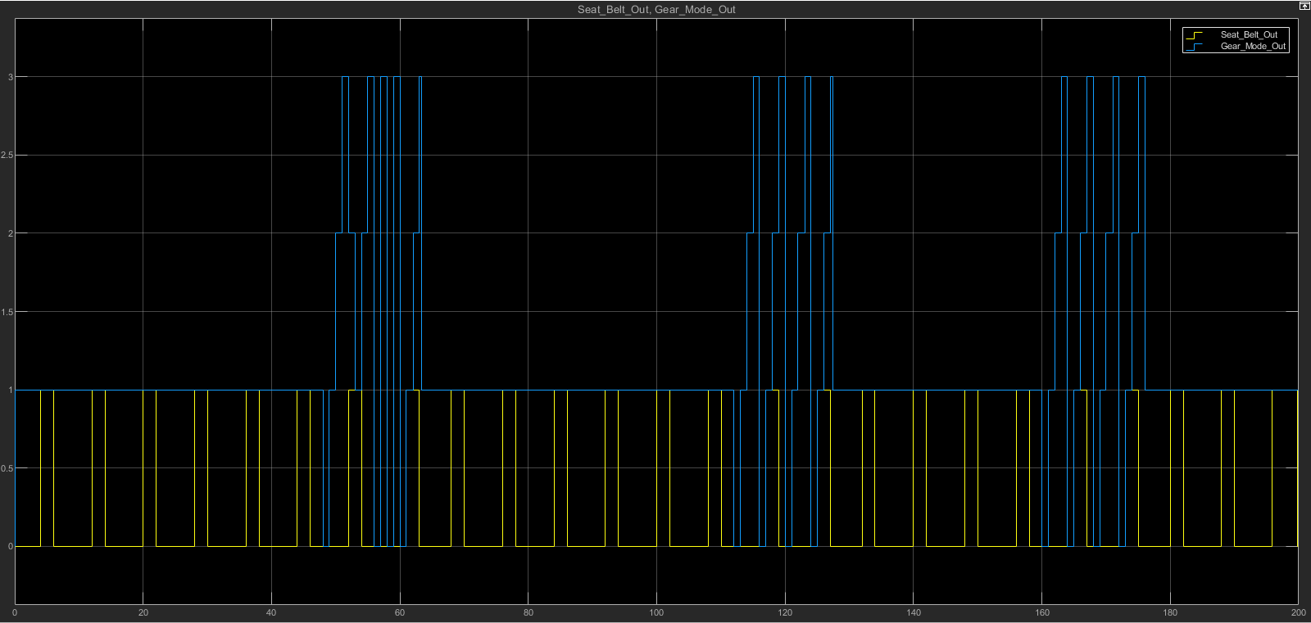

Figure Automated Output for SBR and Gear

## Individual Contribution & Highlights

Seat Belt Reminder Implementation and automation of model.

### Summary

* Applications of MAAB rules
* MCDC coverage report
* Automated HIL model
* Research on BCM features and creation of requirement datasheet
* Model Advisor report for designed MATLAB model
* Algorithm scripting- Sports Tracker
* Industry standard documentation

### Challenges faced and how were they overcome

|  |  |
| --- | --- |
| Challenges | Outcomes |
| MCDC Coverage report | Debugging errors |
| Datasheet creation | Thorough research |
| Automation of model | Simulink |

# Canoe and CAPL scripting [ Team]

## Module

Canoe and CAPL Scripting for Launch Control.

## Topics and Subtopics

1. RPM
2. Gear Shift
3. Turbo Boost
4. Throttle
5. Launch Control mode
6. Break control

## Objectives & Requirements

To implement launch control of McLaren 745LT, using Canoe and CAPL scripting.

## Design

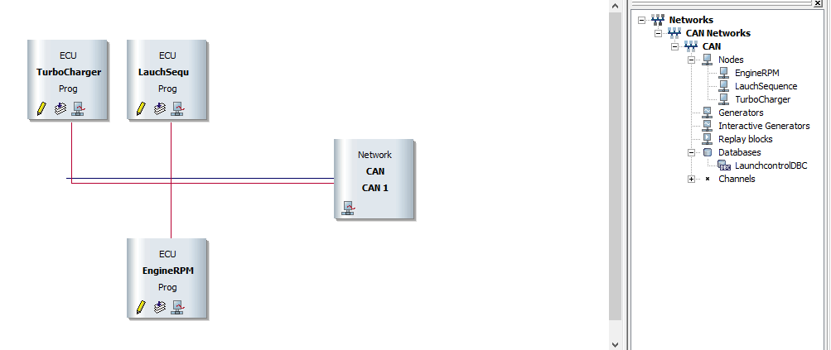

Figure Dashboard Canoe

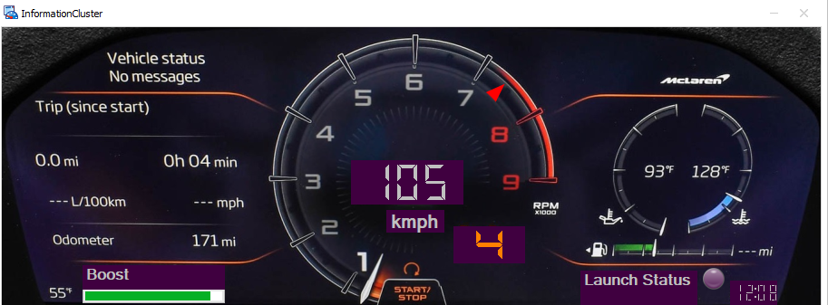

Figure Speedometer

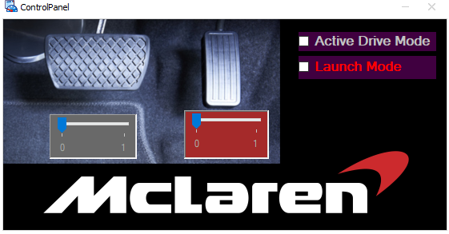

Figure Mode switch, Break and Throttle control

## Test Plan

|  |  |  |  |  |  |
| --- | --- | --- | --- | --- | --- |
| Test ID | Description | Expected IN | Expected OUT | Actual Out | Test Type |
| LC_1 | Lunch Control | 1.Apply brake  2.Turn on Active Mode  3.Turn on Launch Control  4.Apply full Accelerator  5. Release Brake | Launch Control Activated | Lunch Control Activated | Requirement Based |
| LC_2 | Lunch Control | 1.Apply brake  2.Active Mode OFF  3.Apply full Accelerator  4. Release Brake | Launch Control cannot be Activated | Launch control is not Activated | Scenario Based |
| LC_3 | Launch Control | 1.Turn on Active Mode  2.Turn on Launch Control  3.Apply full Accelerator | Launch Control cannot be Activated | Launch control is not Activated | Scenario Based |
| NM_01 | Normal Mode  Drive | Apply Accelerator for speeding up | Vehicle Speed increase | Vehicle Speed is increasing | Requirement Based |
| NM_02 | Stopping | Apply Brake pedal | Vehicle speed decreases | Vehicle Speed is decreasing | Requirement Based |

## Implementation Summary

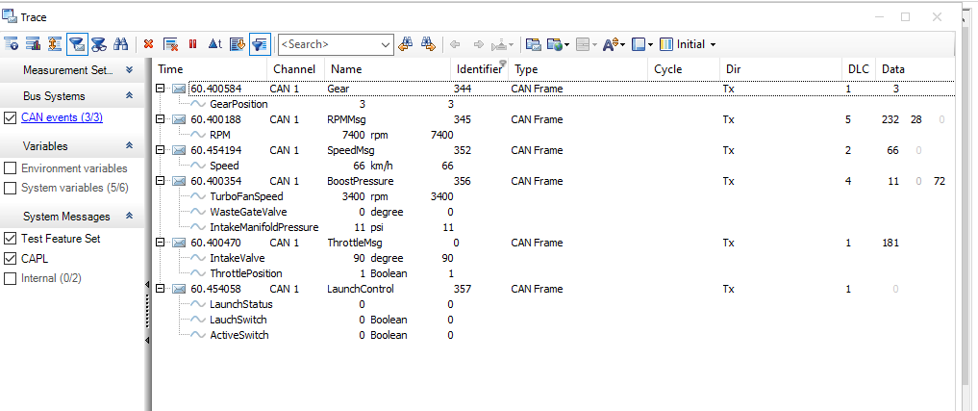

Figure Trace Canoe

### SharePoint Link

[Submission/Submission/BANGALORE/2002BLRGT04/99003745](https://lnttsgroup.sharepoint.com/:f:/r/sites/GEA/Global%20Engineering%20Academy/GENESIS%20%20Jan%202020%20Submission/Submission/BANGALORE/2002BLRGT04/99003745/CANOE?csf=1&web=1&e=UOVlUi)

### SharePoint Dashboard

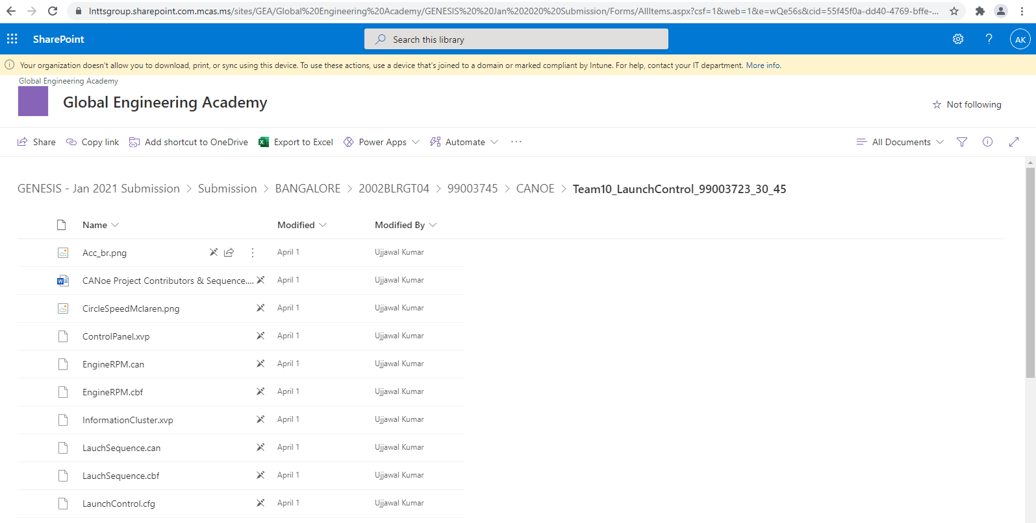

Figure SharePoint Dashboard

## Individual Contribution & Highlights

1. Code contribution for Throttle Position Control
2. Break Control
3. Mode Controller
4. Creating database and system variables.

### Summary

Outcomes:

1. C language and scripting
2. CAN protocols
3. Logging, creation of database and system variables.
4. Tools- Canoe

### Challenges faced and how were they overcome

|  |  |  |
| --- | --- | --- |
| S. No. | Challenges | Resolve |
| 1. | Canoe Tool | Learning and tutorial videos |
| 2. | System Integration | Changing part code and communication between nodes. |

# Control Systems [ Team & Individual]

## Module

Design of controllers for individual and group systems in MATLAB, Simulink and another similar open source software. Analyzing the system based on its speed, accuracy and stability.

## Topics and Subtopics

1. System Plant and controller for drone control and longitudinal control of vehicle.
2. Controller design according to the requirement and order of the system.

## Objectives & Requirements

The longitudinal dynamics of a vehicle is designed by referring the Newton’s law of motion. As per the consideration of Newton’s law of motion the force being exerted to the vehicle is the summation of different individual forces such as Viscous force, Aerodynamic force, braking force and Climbing force or the Downgrade force. This force is also called as gravitational force. These forces play a role of deciding factor for calculating the force exerted in the vehicle to move the vehicle or for the motion of the vehicle.

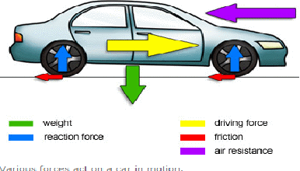

Figure Longitudinal Control

Longitudinal dynamics of the vehicle as governed by the newton’s law

$$F_{d}=M\frac{dv}{dt}+F_{a}+F_{g}$$

Where $M\frac{dv}{dt}$ is inertia force.

$F_{a }$ is aerodynamic drag.

$F_{d}$ is aerodynamic drag.

$v_{w }$ is the wind gust speed.

M is the mass of vehicle and passenger.

θ is the road grade.

Ca is aerodynamic drag coefficient.

The state Variables

$$v^{'}=\frac{1}{M}(F_{d}-C_{a}v^{2})$$

$$F_{d}^{'}=\frac{1}{T}C_{1}u\left(t-T\right)-F_{d}$$

$$y=v$$

Differentiating the above equation

$$\frac{d}{dt}v^{'}=\frac{1}{M}(-2C_{a}vδv+δF_{d})$$

$$\frac{d}{dt}F_{d}^{'}=\frac{1}{T}C_{1}δu\left(t-T\right)-F_{d})$$

$$y=δv$$

The transfer function of the above equation is

$$\frac{Δv(s)}{Δu(s)}=\frac{\frac{C_{1}}{MT}}{(s+2C_{a}v/M)(s+\frac{1}{T})(s+\frac{1}{τ})}$$

The parameters chosen are:

$C_{1}$ = 743; T=1s; $τ$ =1s; M=1500kg; $C_{a}$ = 1.19 N/(m/s^2); g =9.8 m/s^2.

Longitudinal control is used in cruise control system.

##### Individual system is for drone pitch control

A second order differential equation describing the rotational dynamics for the platform pitch angle can be written as:

θ'' = m/Jy

where m is the pitch moment of the wing, which is given by the following expression:

m =1/2(((V^2) ρ*S*c*Cm)

Cm = Cmac + Cmα*α + Cmδe*δe + Cmq*Q*(c/V)

Assuming that in steady hover flight θ = α and Cmac = 0 and substituting both m & Cm, we get

θ'' =ρ*(V^2) *S*c*2*Jy[Cmαθ + Cmδe*δe + Cmq*(c/V)dθ/dt]

Cmα = −0.145 and Cmδe = 0.65 Cmq = −10 α = 0

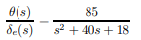

%The derivative Cmα  
% represents the variation of the pitching moment with respect to  
% the angle-of-attack αThe derivative Cmα  
% represents the variation of the pitching moment with respect to  
% the angle-of-attack α.  
% S 0.18m2 Wing Reference area  
% c 0.3m Wing chord  
% ρ 1.225kg/m3 Air density  
% V 10m/s Wind velocity (airflow)  
% Jy 0.0254kg.m y-axis moment of inertia

## Requirements

1. Longitudinal control for vehicle’s plant and controller design.
2. Pitch control for drone controller design and analysis.

## Design for Longitudinal Control

Transfer function:

$$\frac{Δv(s)}{Δu(s)}=\frac{\frac{C_{1}}{MT}}{(s+2C_{a}v/M)(s+\frac{1}{T})(s+\frac{1}{τ})}$$

Roots of the equation are:

Pole 1: - $2C_{a}v/M$

Pole 2: -1/T

Pole 3: -1/τ

Order of the equation: Third order equation.

## Plant Model with P, PI, PD And PID controller

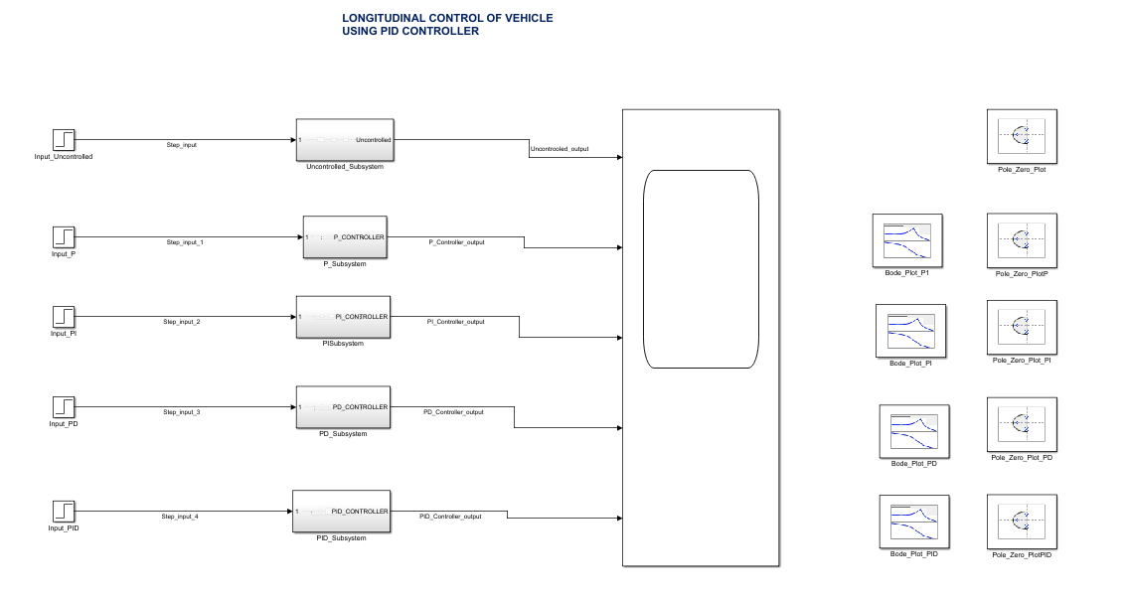

Figure Plant Model PID

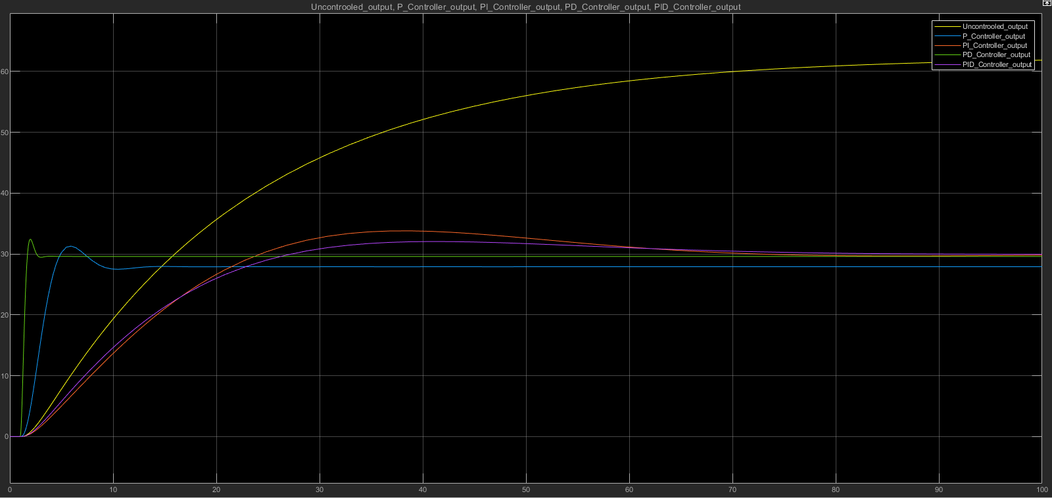

Figure PID scope output

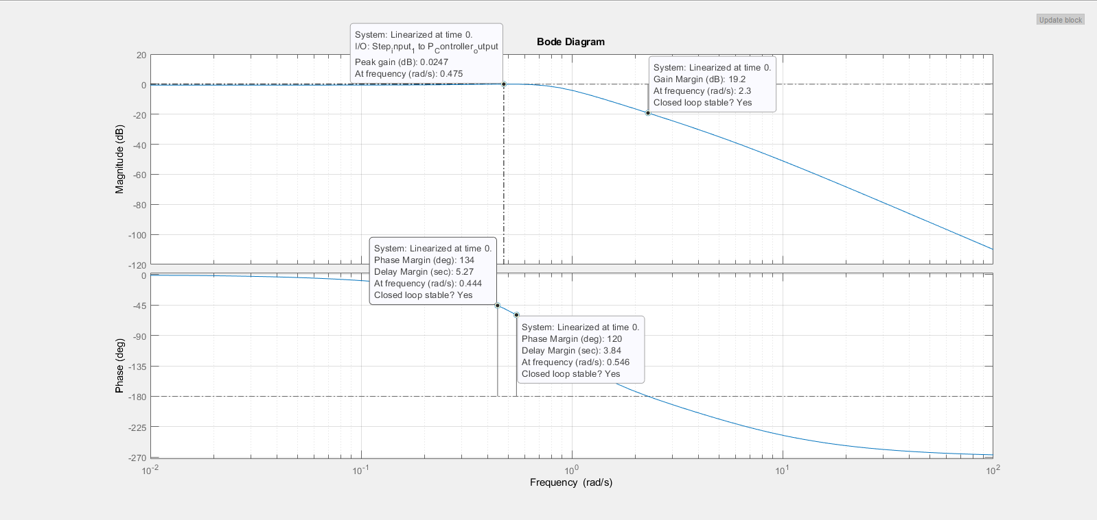

Figure Bode Plot P

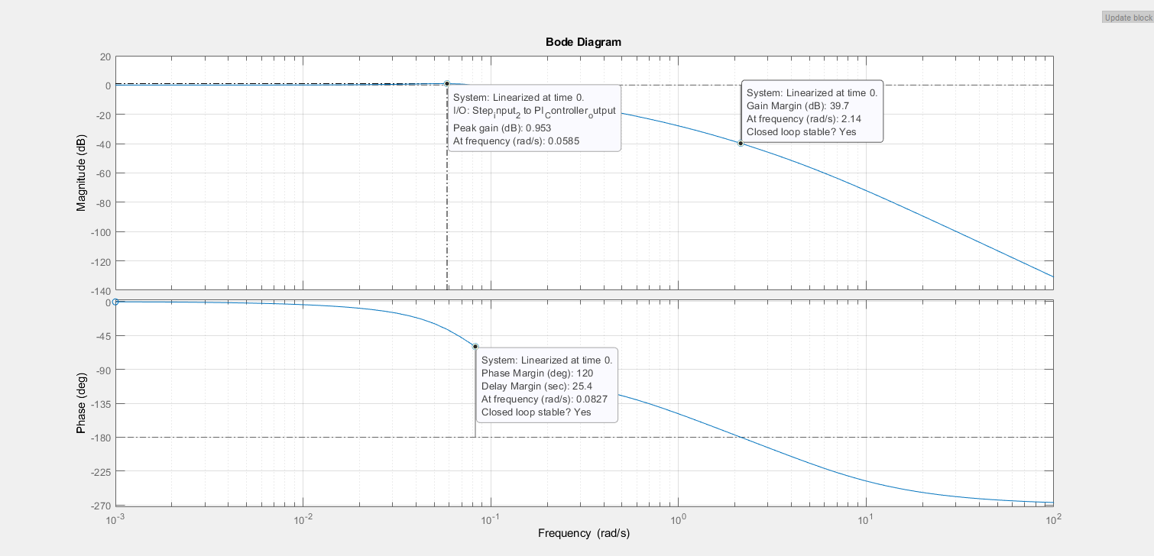

Figure Bode Plot PI

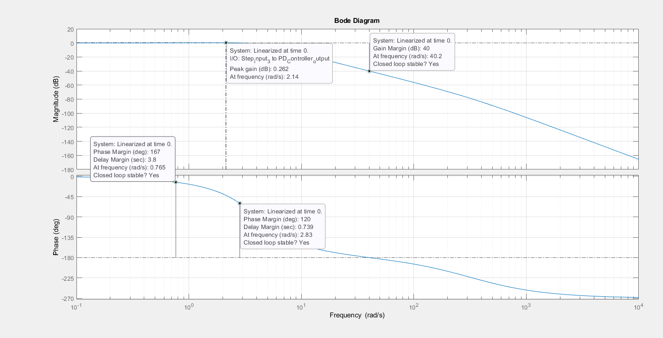

Figure Bode Plot PD

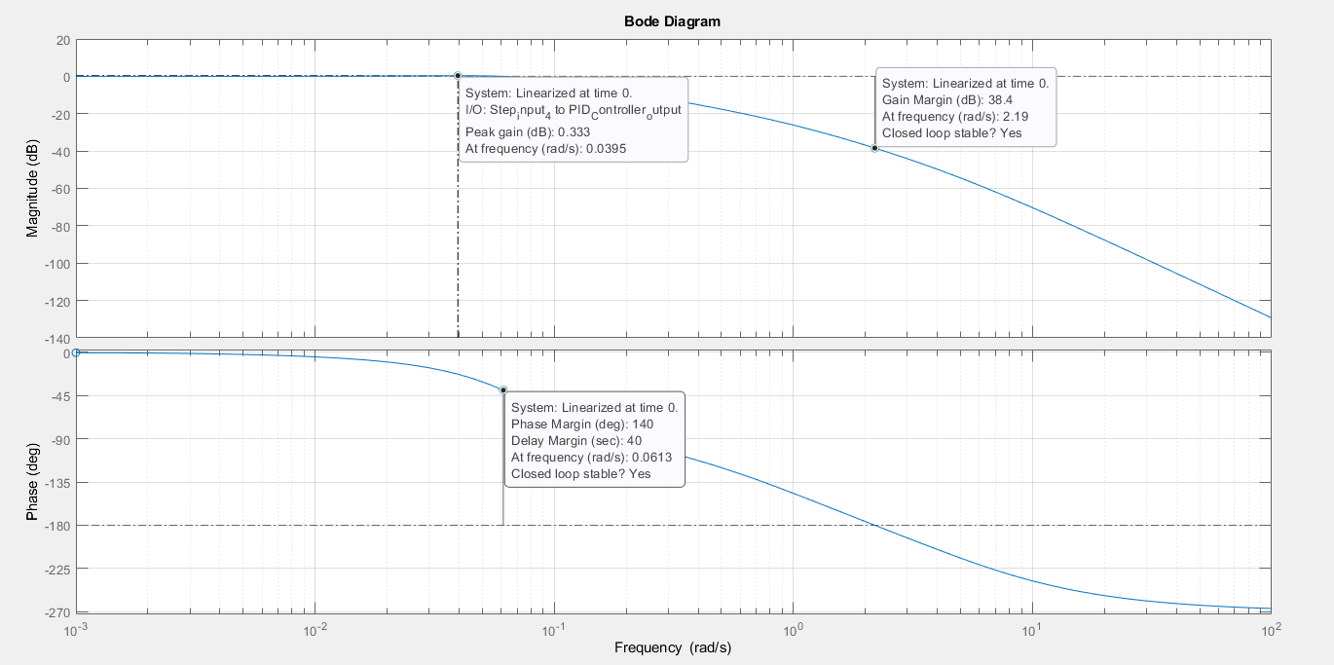

Figure Bode Plot PID

### Analysis

* P Controller

Rise Time- 2.189s

OS- 11.798%

Settling time- 7.4s

* PI

Rise Time- 16.417s

OS- 13.068%

Settling time-63.5s

* PD

Rise Time- 4.62197s

OS- 9.341%

Settling time- 1.52s

* PID

Rise Time- 17.780s

OS- 6.989%

Settling time- 66.2s

* Accuracy- PD controller is the accurate followed by P>PI>PID as setting for it is least among the others.
* Speed- PD>P>PI PID

(As rise time is least for PD).

* Overshoot is maximum in PI>P>PD>PID

Therefore, stability of PID is maximum followed by PD>P>PI.

* Poles- Poles are located on the left side of the s-plane in PID, making the system stable.

## Plant Model with lead lag compensator

Lead Lag Controller for Longitudinal control of Vehicle

Team 3 Vipul Sakunia 99003723 Archita Modi 99003724 Ujjawal Kumar 99003745 Ravikumar M Pise 99003747

Transfer Function: 72

Tool Analysis 72

Analysis for Lead Compensator **Error! Bookmark not defined.**

## Transfer Function:

[(C1/MT)/(s+2Cav) (s+1/T) (s+1/tau)]

## Tool Analysis

C1=743;  
T=1;  
tau =0.2;  
M=1500;  
Ca=1.19;  
v=30;  
s=tf('s')  
  
sys=tf([C1/M*T],[1,2*Ca*v/M]);  
sys2=tf([1],[1,1/T]);  
sys3=tf([1],[1,1/tau]);  
sysf=sys2*sys3*sys  
figure(1)  
step(sysf)  
title("Main TF Step response")  
  
Gc=(s+.03)/(s+.04);  
Gc1=(s+1)/(s+10);  
lead=sysf*Gc*Gc1  
p=pole(sysf)  
z=zero(sysf)  
  
figure(2)  
pzmap(sysf)  
title("Pole zero map of TF")  
stepinfo(sysf)  
  
Gcloseloop=lead/(1+lead)  
p1=pole(lead)  
z1=zero(lead)  
figure(3)  
opt = stepDataOptions('InputOffset',0,'StepAmplitude',230);  
step(Gcloseloop,opt)  
title("Longitudinal Lead Lag Response")  
stepinfo(Gcloseloop)  
  
figure(4)  
pzmap(Gcloseloop)  
title("Pole Zero Lead-Lag feedback")  
  
% bode plots  
figure(5);  
subplot(2,2,1);  
bode(sysf)  
[Gm,Pm,Wcg,Wcp] = margin(sysf)  
title('Bode of the OL TF');  
  
subplot(2,2,2);  
bode(Gcloseloop)  
[Gm,Pm,Wcg,Wcp] = margin(Gcloseloop)  
title('Bode of the CL TF');  
  
% subplot(2,2,3);  
% bode(lead)  
% [Gm,Pm,Wcg,Wcp] = margin(lead)  
% title('Bode of the LEAD TF');

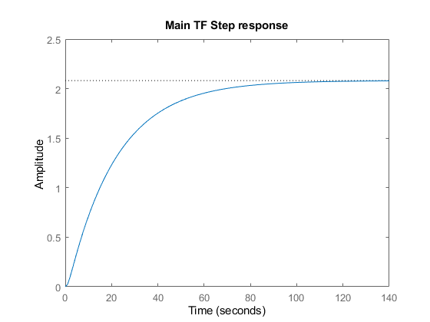

Figure Main TF response

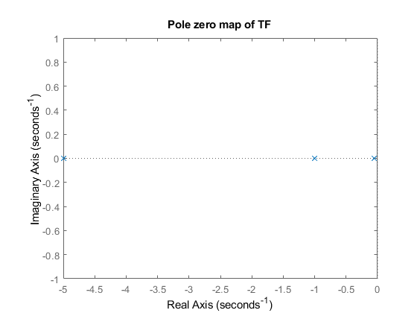

Figure Pole Zero Map of main TF

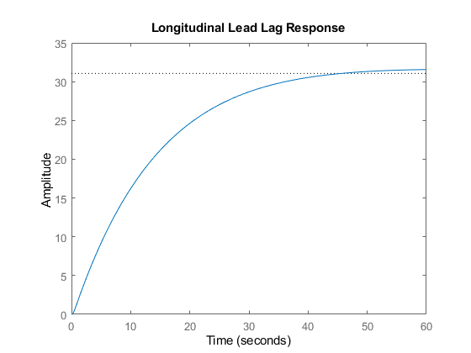

Figure Response with Lead-Lag Controller

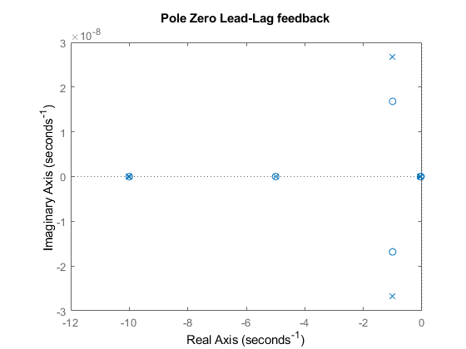

Figure Lead Lag Pole Zero Map

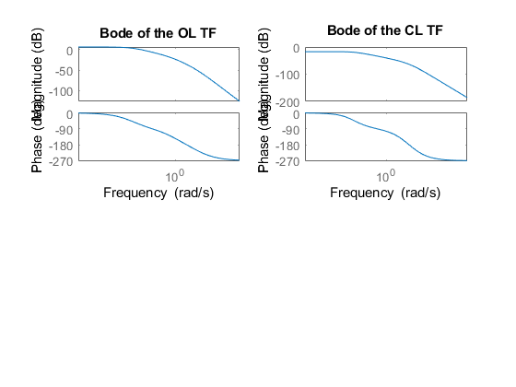

Figure Bode Plots

### Analysis for Lead Compensator

Risetime: 25.8096 Settling Time: 39.1411 Settling in: 0.1215 Settling Max: 0.1374 Overshoot: 1.7407 Undershoot: 0 Peak: 0.1374 Peak Time: 66.5908

Without Compensator-- Risetime: 46.2140 Settling Time: 83.4147 Settling Min: 1.8800 Settling Max: 2.0798 Overshoot: 0 Undershoot: 0 Peak: 2.0798 Peak Time: 153.8282

Speed-- speed of response is more in lead lag compensator Accuracy-- Lead Compensator provides higher accuracy Stability of system without compensator is high because overshoot is zero. The system is stable in both the cases from the frequency analysis as the gain margin, phase margin and the crossover frequency are all positive.

## Plant Model with Fuzzy Controller

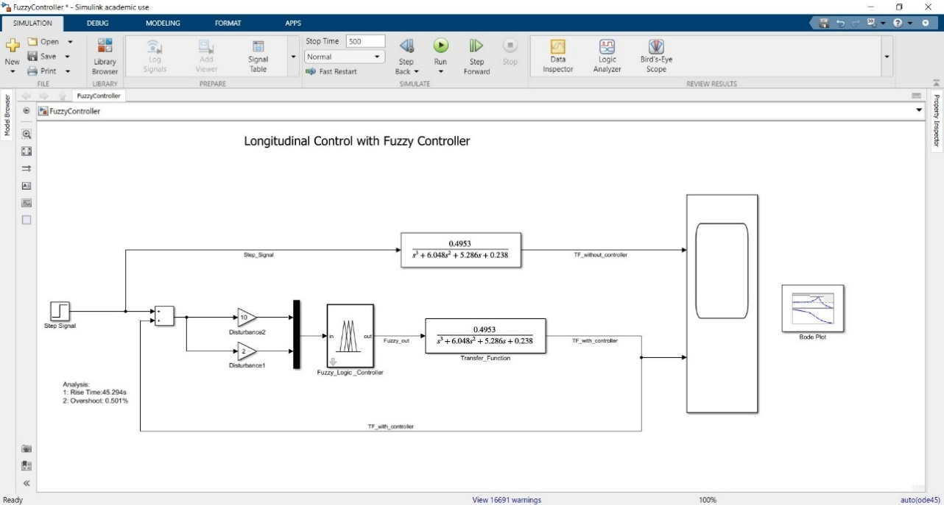

Figure Fuzzy Logic Implementation

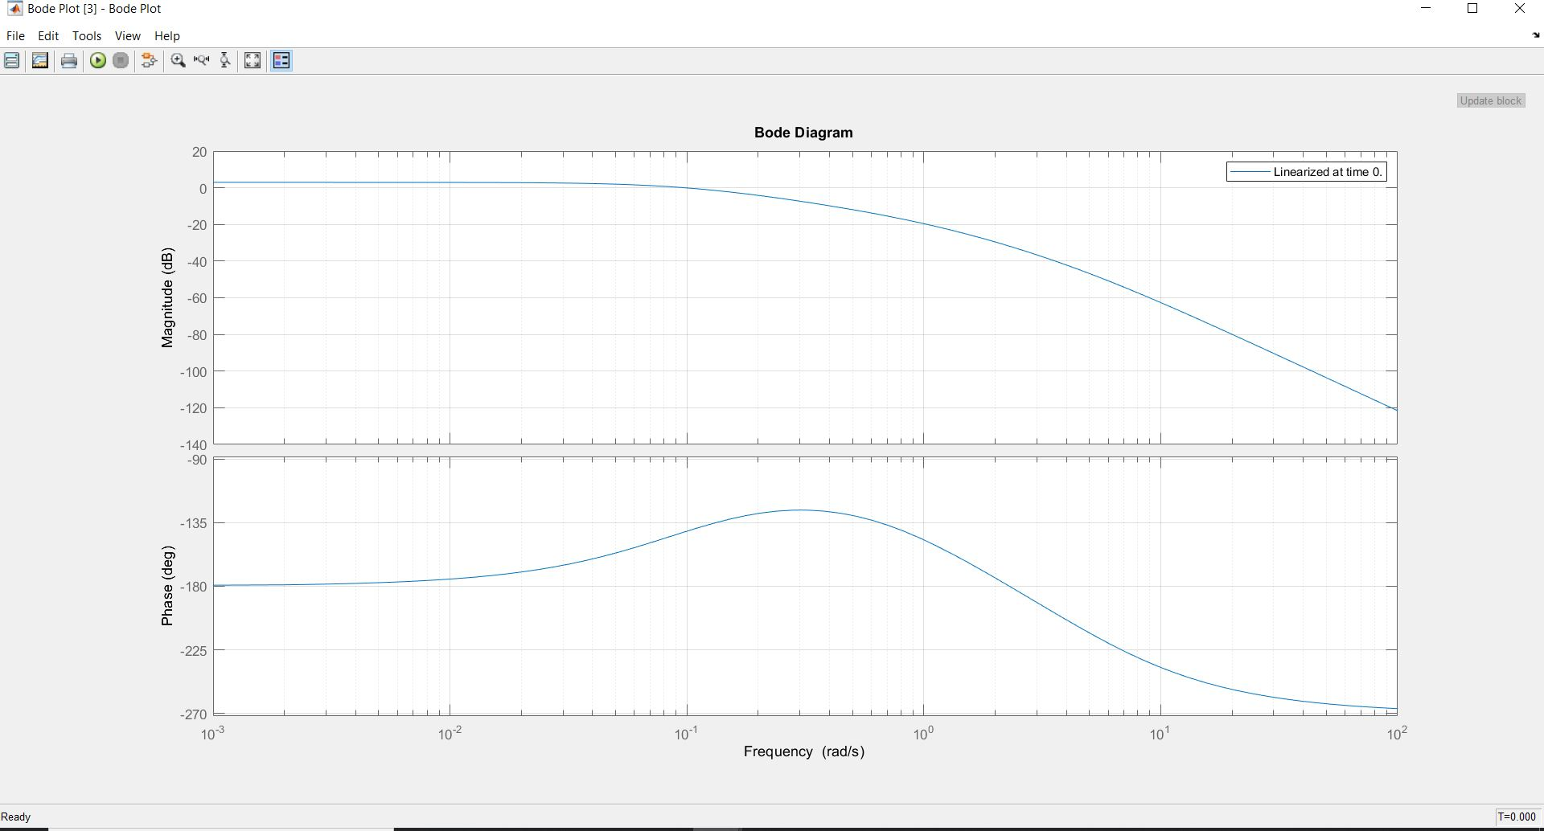

Figure Fuzzy Bode Plot

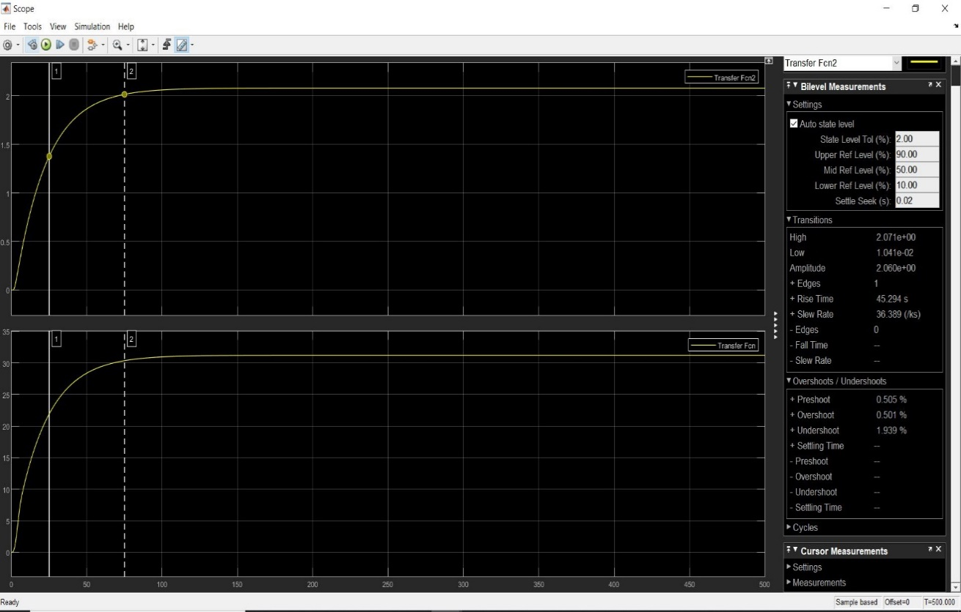

Figure Fuzzy Output

* Rise Time: 45.294s
* Overshoot: 0.501%

## Longitudinal Control with Disturbance using PI, PD, PID Control.

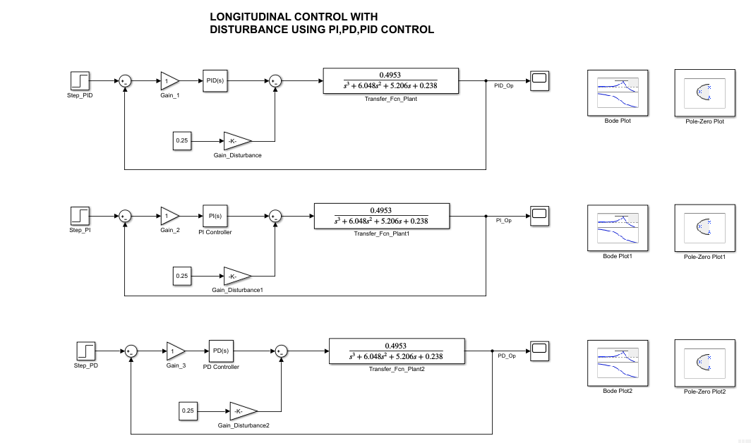

Figure PID with Disturbance

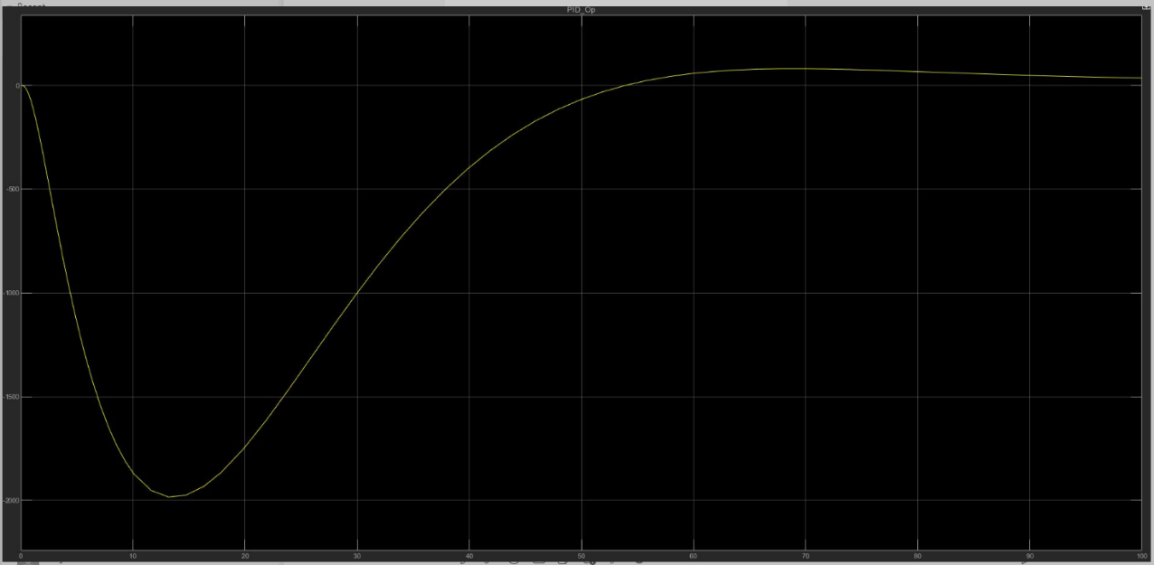

Figure Disturbance with PI Output

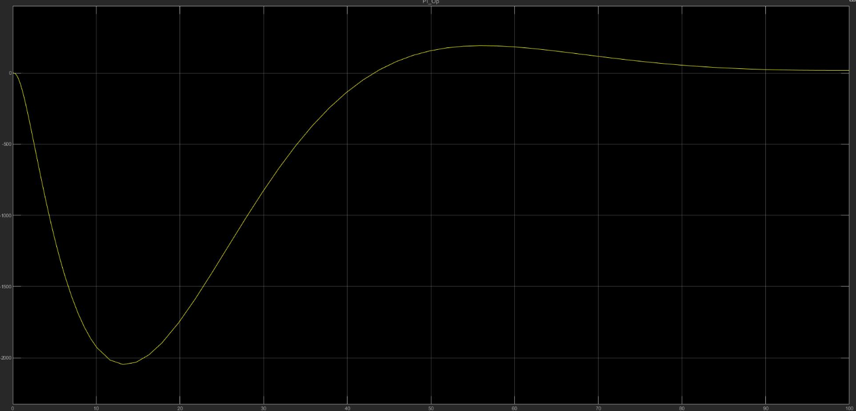

Figure Disturbance with PD Output

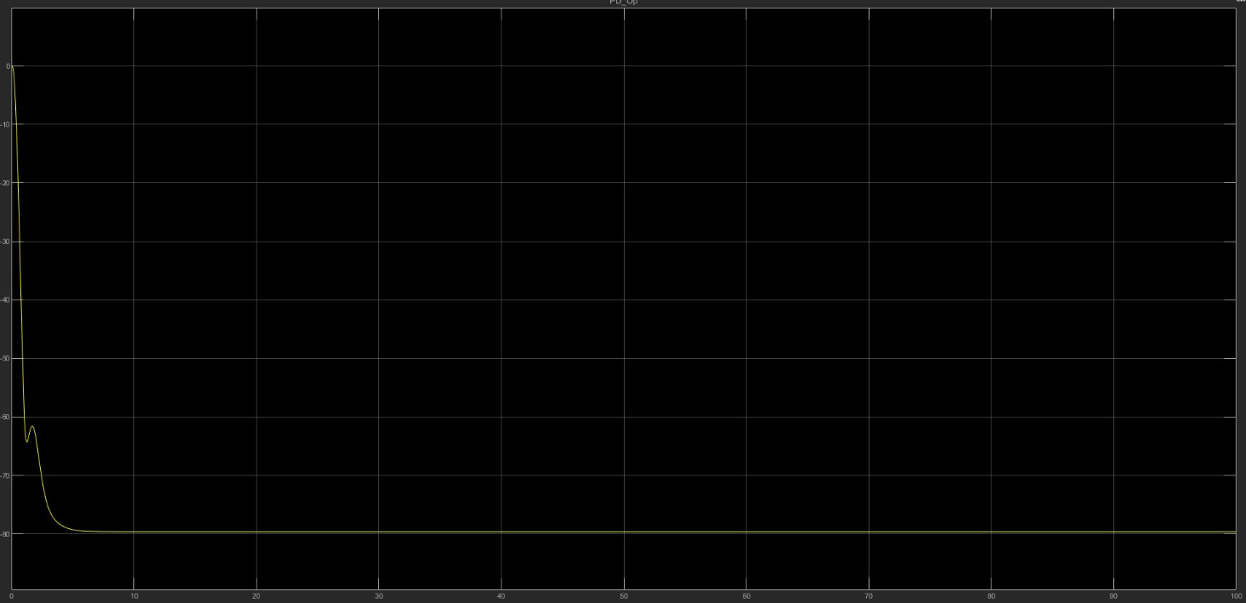

Figure Disturbance with PID Output

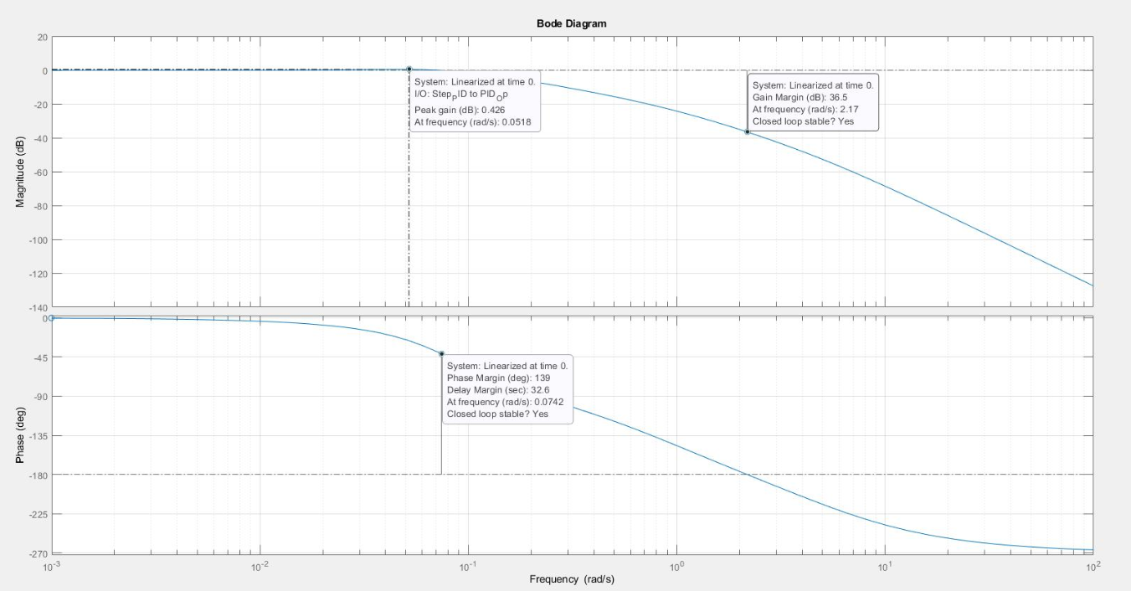

Figure Bode Plot PI

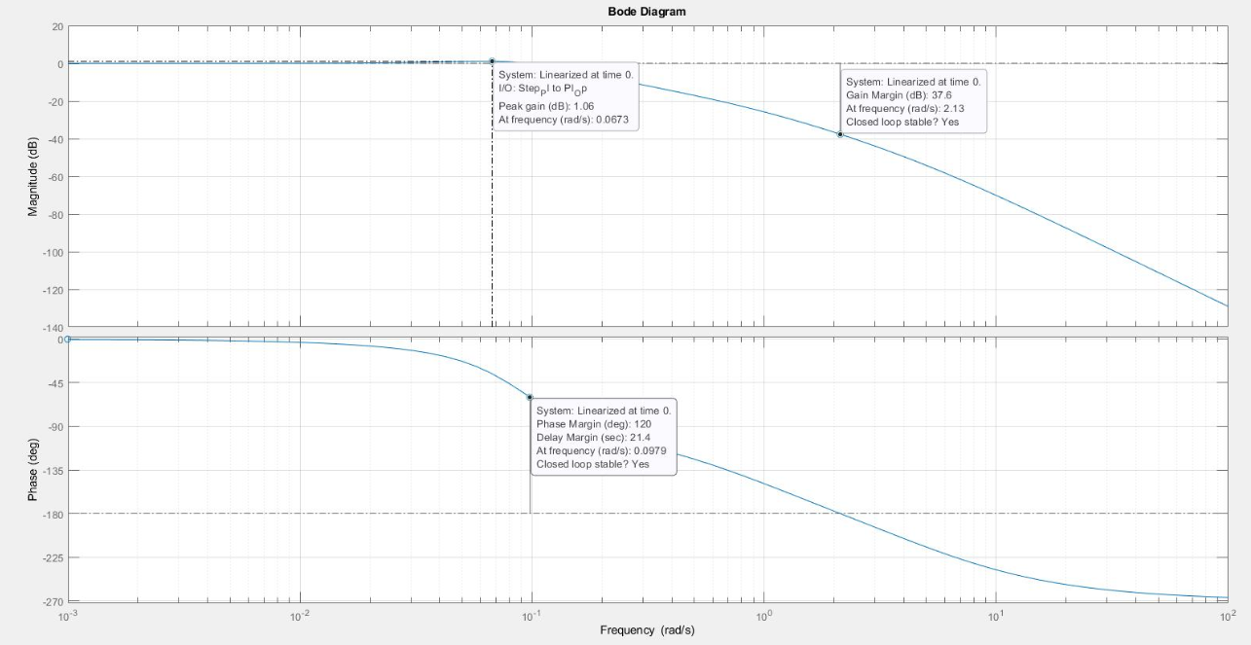

Figure Bode Plot PD

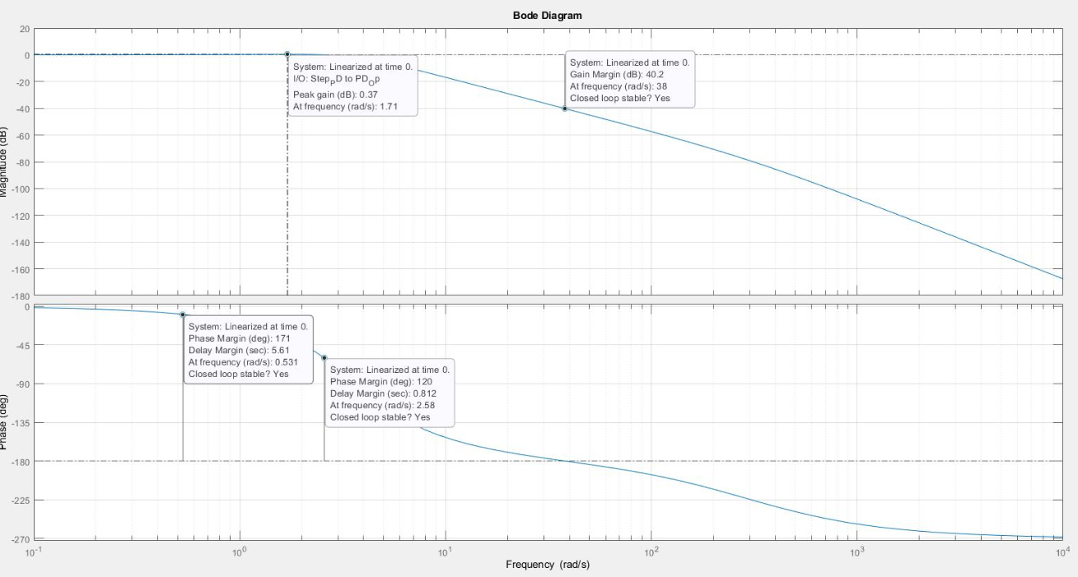

Figure Bode Plot PID

### Analysis

1. PID Controller  
   Kp=0.8212  
   Ki=0.070275 Kd-0.1688  
   Rise time: 14.9 s  
   Settling time: 58.6s Overshoot: 7.39%
2. Pl Controller -0.70851  
   Ki=0.0811  
   Rise time: 13.7s  
   Settling time: 55.3s Overshoot: 13.2%
3. PD Controller  
   Kp=0.501  
   Kd= 28.5792 Rise time: 13.7s  
   Settling time: 55.3s  
   Overshoot: 13.2%
4. Speed-PD-PI-PID  
   System with PD, PI Controllers. speed is High because Rise time is less.
5. Accuracy=PD>=PI>PID  
   System with PD, PI Controllers, Accuracy is more because Setting time is less.  
   Stability PID>PD>PI

### SharePoint Link

[https://lnttsgroup.sharepoint.com/Submission/Forms/Longitudinal](https://lnttsgroup.sharepoint.com/sites/GEA/Global%20Engineering%20Academy/GENESIS%20%20Jan%202020%20Submission/Forms/AllItems.aspx?originalPath=aHR0cHM6Ly9sbnR0c2dyb3VwLnNoYXJlcG9pbnQuY29tLzpmOi9zL0dFQS9HbG9iYWwlMjBFbmdpbmVlcmluZyUyMEFjYWRlbXkvRWl6d2trOGZYYnRDcU11b2p4eUhlZzhCYTJUOE5sMVA4R0VTVU5sUmxrNUt4dz9ydGltZT1lTkRfdV9fXzJFZw&viewid=c6456521%2D0829%2D4568%2Db8d1%2D27a784675a0f&id=%2Fsites%2FGEA%2FGlobal%20Engineering%20Academy%2FGENESIS%20%20Jan%202020%20Submission%2FSubmission%2FBANGALORE%2F2002BLRGT04%2F99003723%2FControl%20Systems%2FTeam3%5FLongitudinal%5FControl)

## Individual Contribution & Highlights

Lead-lag controller for Longitudinal control of vehicle.

### Pitch Control for Drone

## Math Analysis

roots= −22.7 ± 91.45i and −4.62

## Pitch control of drone with controllers

Tool Analysis 83

Analysis and Time Response result 87

Pole mapping **Error! Bookmark not defined.**

## Tool Analysis

numerator = 85;  
denominator = [1,40,18];  
  
sys_ol = tf(numerator,denominator);  
sys_cl = feedback(sys_ol,1);  
  
[GC_PI,info_PI] = pidtune(sys_ol,'PI');  
sys_cl_PI = feedback(sys_ol * GC_PI,1);  
  
[GC_PD,info_PD] = pidtune(sys_ol,'PD');  
sys_cl_PD = feedback(sys_ol * GC_PD,1);  
  
[GC_PID,info_PID] = pidtune(sys_ol,'PID');  
sys_cl_PID = feedback(sys_ol * GC_PID,1);  
  
% input response plots  
figure(1);  
subplot(2,2,1);  
step(sys_ol);  
title('Step of OL TF');  
  
subplot(2,2,2);  
step(sys_cl);  
title('Step of CL TF');  
  
% controller plots  
figure(2);  
subplot(2,2,1);  
step(sys_cl)  
title('CL Uncontrolled response of TF');  
stepinfo(sys_cl)  
% [zeta,wn]=damp(sys_cl)  
  
subplot(2,2,2);  
step(sys_cl_PI)  
title('CL PI controlled response of TF');  
stepinfo(sys_cl_PI)  
[zeta,wn]=damp(sys_cl_PI)  
  
  
subplot(2,2,3);  
step(sys_cl_PD)  
title('CL PD controlled response of TF');  
stepinfo(sys_cl_PD)  
  
  
subplot(2,2,4);  
step(sys_cl_PID)  
title('CL PID controlled response of TF');  
stepinfo(sys_cl_PID)  
  
  
% Bode plots  
figure(3);  
subplot(2,2,1);  
bode(sys_ol)  
title('OL TF');  
  
subplot(2,2,2);  
bode(sys_cl)  
title('CL uncontrolled TF');  
  
subplot(2,2,3);  
bode(sys_cl_PID)  
title('CL PID controlled TF');

ans =   
  
 struct with fields:  
  
 RiseTime: 0.7975  
 SettlingTime: 1.4422  
 SettlingMin: 0.7439  
 SettlingMax: 0.8247  
 Overshoot: 0  
 Undershoot: 0  
 Peak: 0.8247  
 PeakTime: 2.6469  
  
  
ans =   
  
 struct with fields:  
  
 RiseTime: 1.5488  
 SettlingTime: 5.8888  
 SettlingMin: 0.9142  
 SettlingMax: 1.1421  
 Overshoot: 14.2109  
 Undershoot: 0  
 Peak: 1.1421  
 PeakTime: 3.3865  
  
  
zeta =  
  
 0.8811  
 0.8811  
 38.9665  
  
  
wn =  
  
 0.5865  
 0.5865  
 1.0000  
  
  
ans =   
  
 struct with fields:  
  
 RiseTime: 0.0395  
 SettlingTime: 0.1282  
 SettlingMin: 0.9026  
 SettlingMax: 1.0999  
 Overshoot: 11.0251  
 Undershoot: 0  
 Peak: 1.0999  
 PeakTime: 0.0812  
  
  
ans =   
  
 struct with fields:  
  
 RiseTime: 1.7539  
 SettlingTime: 6.3719  
 SettlingMin: 0.9078  
 SettlingMax: 1.0617  
 Overshoot: 6.1683  
 Undershoot: 0  
 Peak: 1.0617  
 PeakTime: 3.8941

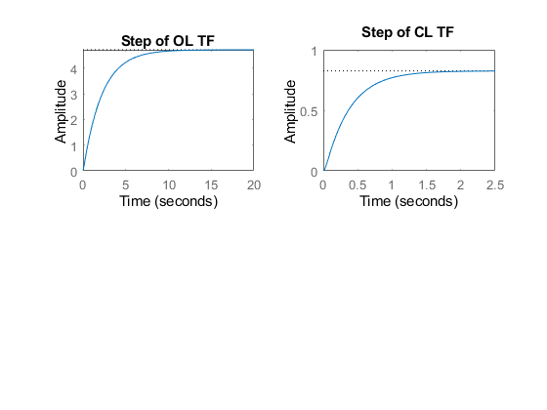

Figure Step Response Drone

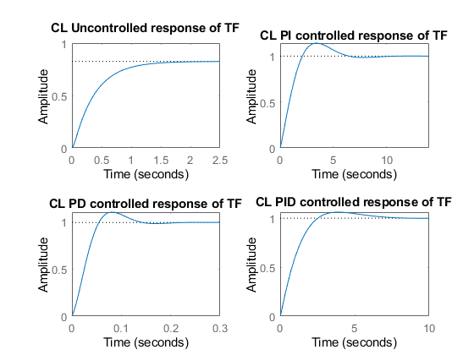

Figure Response with Controllers

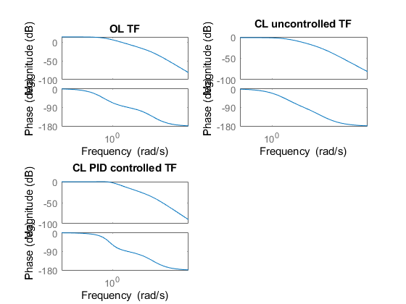

Figure Bode Plots for Drone PID

## Analysis and Time Response result

Rising time is increased so the speed is decreased. settling time is increased, accuracy decreased. Overshoot increased Peak is amplified of the system. Pole at origin is added. Eliminates the steady state error.

Rising time is decreased, speed of the system is increased. settling time is decreased, accuracy increased to a large extent.

Overshoot increased showing less stability from closed loop. Peak is amplified of the system but peak time decreased.

Zero at origin is added No affect to steady state error. Does not change the stability of the system.

Rising time is increased, speed of the system is decreased. settling time is increased, accuracy decreased. Overshoot increased. Peak is amplified of the system.

The phase margin of PID controlled system is +ve Gain margin is infinite which make the system stable Can be cross checked by the roots and pole of the system as they lie on the negative x axis. Affects all the parameters of the system. Adds a pole & a zero at the origin. the steady state error of the system is reduced because of I controller.

Overall Analysis Stability- CL>PID>PD>PI Speed- PD>CL>PI>PID Accuracy- PD>CL>PI>PID

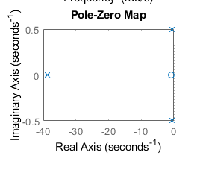

Figure Pole Zero Map

### SharePoint Link

[https://lnttsgroup.sharepoint.com/sites/GEA/GlobalSubmission/Forms/DronePControl](https://lnttsgroup.sharepoint.com/sites/GEA/Global%20Engineering%20Academy/GENESIS%20%20Jan%202020%20Submission/Forms/DronePControl)

### Implementation Summary

Pitch control for drone by second order equation in open and closed loop in MATLAB script.

## Summary

Outcomes:

1. Plant and controller design and control systems.
2. Migration of models and scripts in various open source software.
3. Analysis of system’s speed, accuracy and stability.
4. Tools- OpenModelica, GNU Octave.

## Individual Contribution & Highlights

1. Longitudinal Control for vehicle with lead-lag compensator.
2. Research for various controllers that can be used for the chosen plant.
3. Drone pitch control.
4. Migration of model and script in GNU octave and open modelica.

### Challenges faced and how were they overcome

|  |  |
| --- | --- |
| Challenges | Resolution |
| Equation and system knowledge | By going through various research papers |
| Scripting in MATLAB | Through examples and help documentation. |